AI Software Development Internship
Week 5: Detailed Task Sheet
ZAINAB AKRAM

AI Software Development Internship
Week 6 — Detailed Task Sheet
PART A — LANGCHAIN FUNDAMENTALS & LCEL
Challenge:
- Trace, in writing, exactly what data type flows out of each stage of the chain above — guard_short_questions fi the dict-of-runnables step fi prompt fi model fi StrOutputParser. If you can't state the type at every arrow, you don't yet understand LCEL well enough to debug it later — read the LangChain Expression Language docs before continuing.
- Break the chain on purpose (pass a 1-character question) and read the raised error's stack trace — identify exactly which stage raised it, without adding a single print statement.
Code:
Challenge 1:
lcel_rag.py
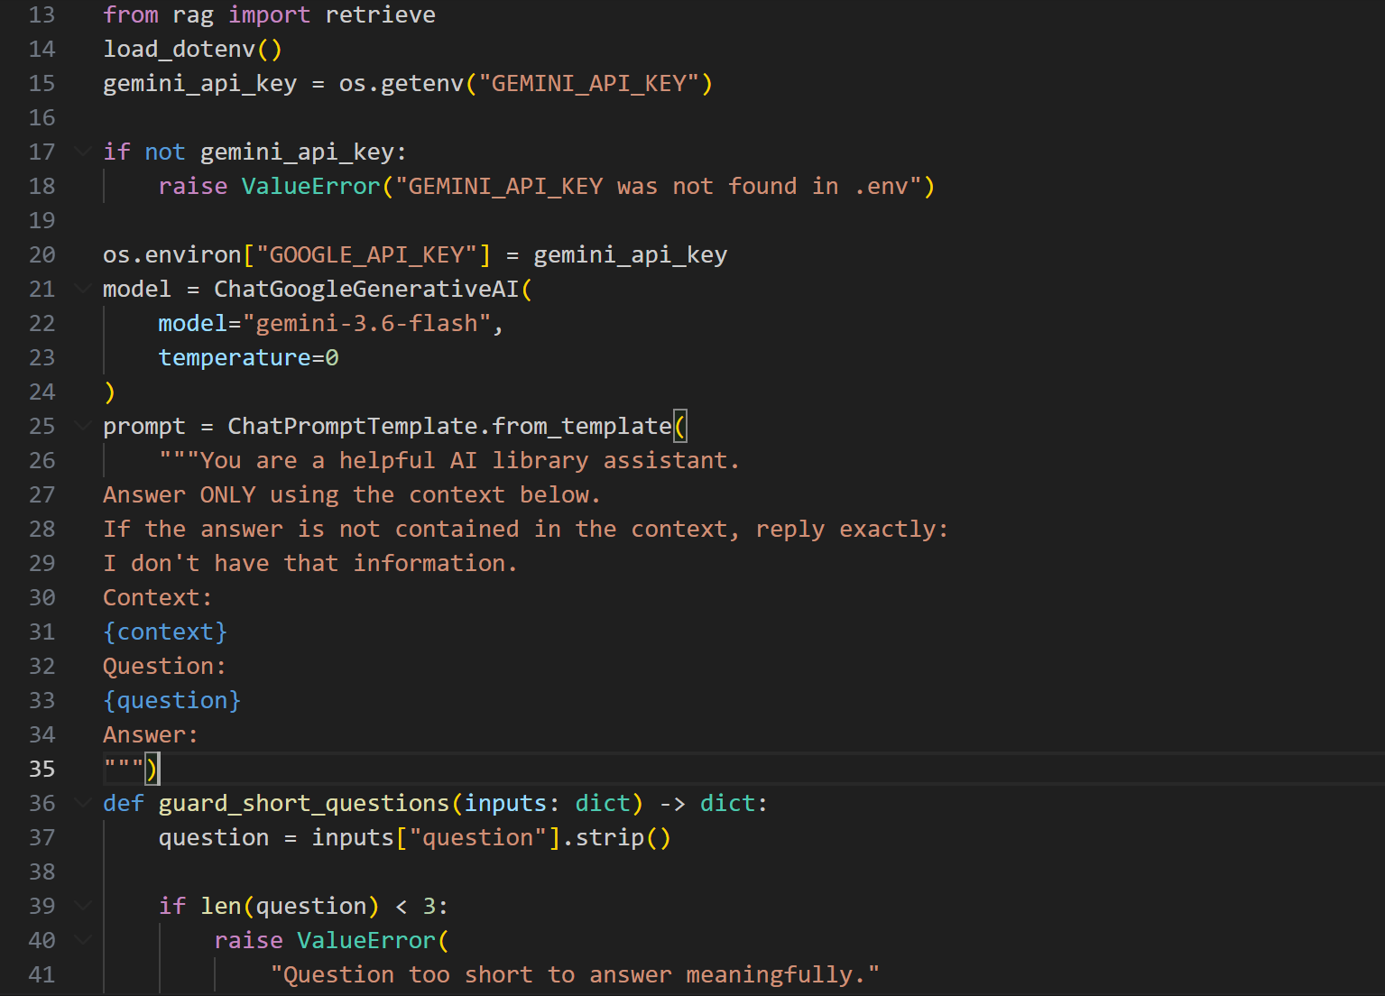
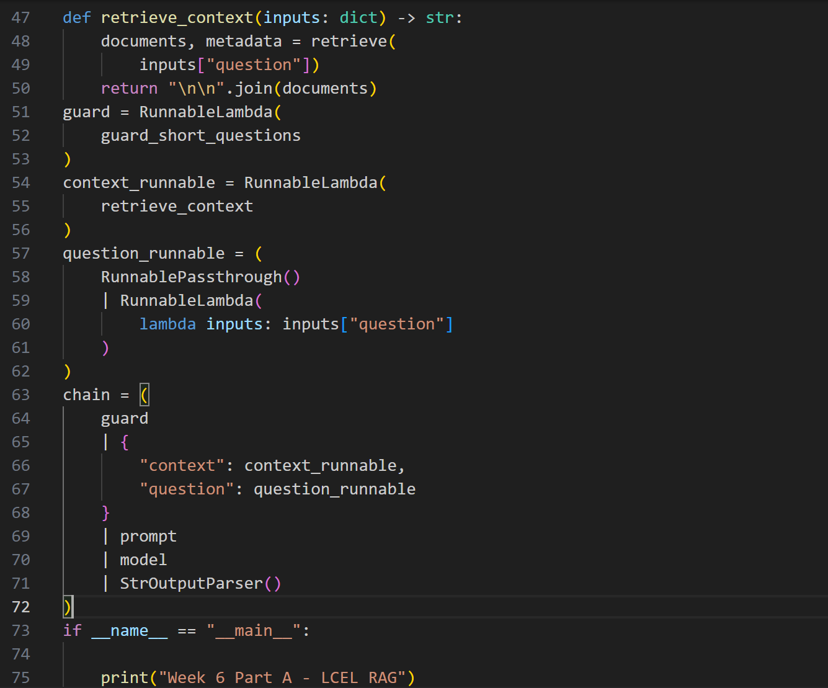
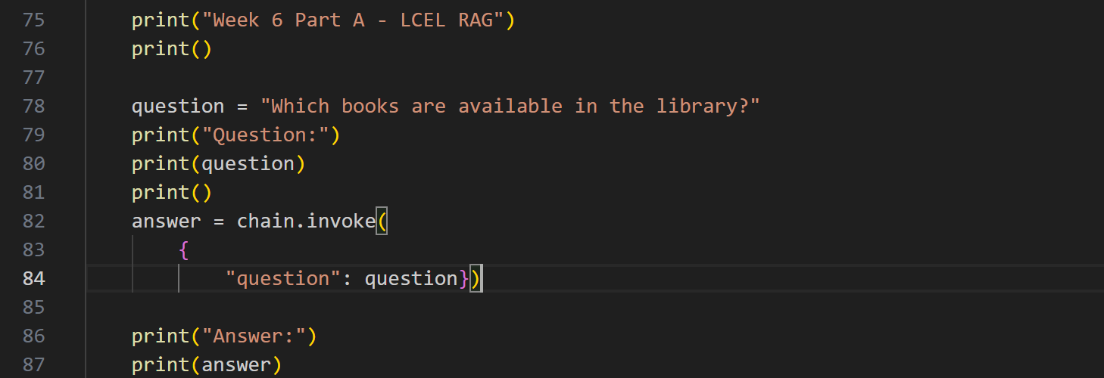
Challenge 2:
lcel_rag.py
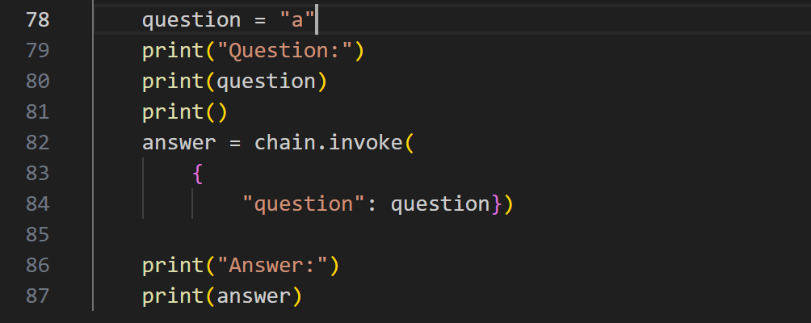
part-a-notes.md
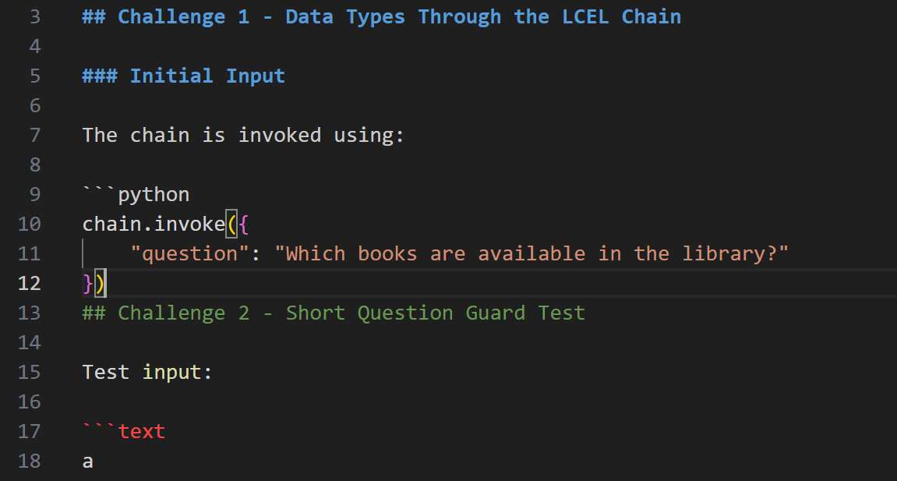
Output:
Challenge 1 output:
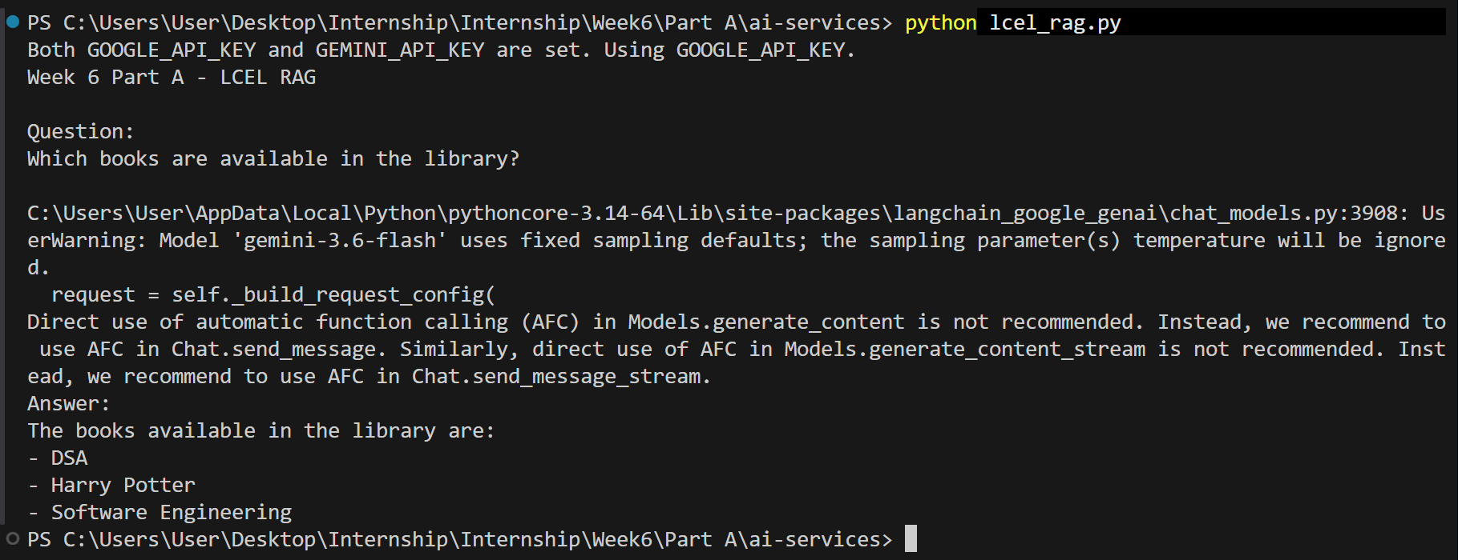
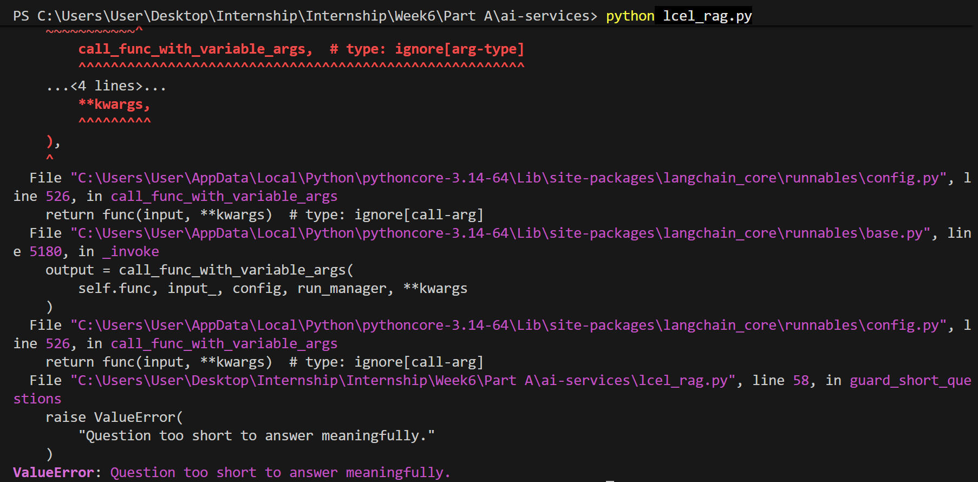
Challenge 2 output:
PART B — DOCUMENT LOADERS, SMARTER SPLITTING & ADVANCED RETRIEVAL
Challenge:
- Run the same 5 test questions from Week 5's manual RAG evaluation against both the plain retriever and the MultiQueryRetriever. For any question where they disagree, inspect the reformulated queries LangChain generated (turn on verbose logging) and explain why the extra queries helped or didn't.
- Harder still: Find one realistic question where MultiQueryRetriever makes results worse (pulls in an irrelevant chunk it wouldn't have retrieved with a single query) and explain, in writing, the trade-off this technique makes.
Code:
Challenge 1:
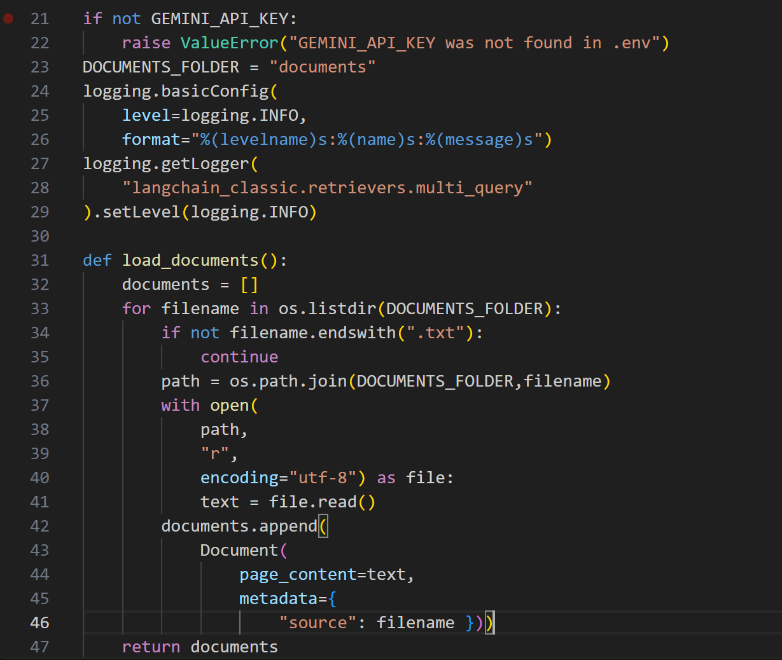
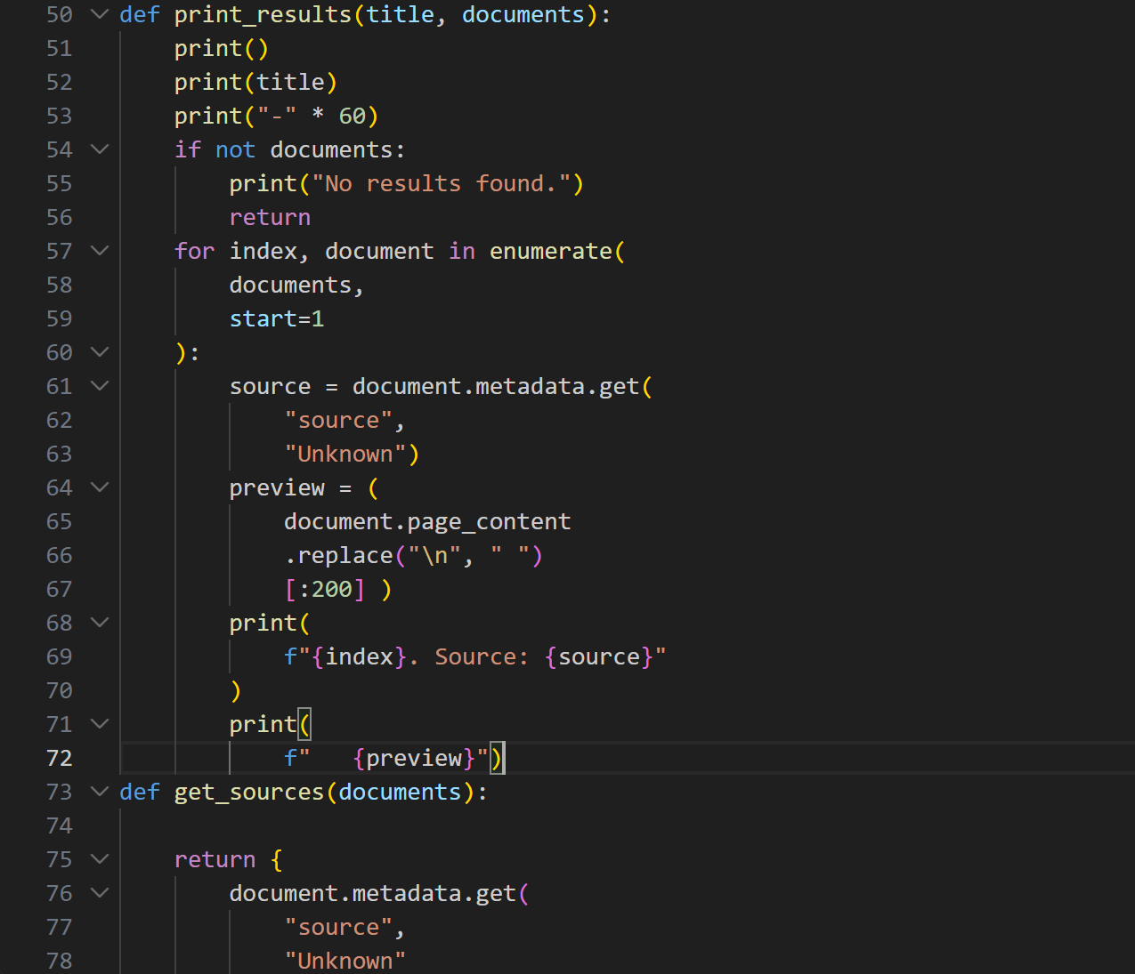
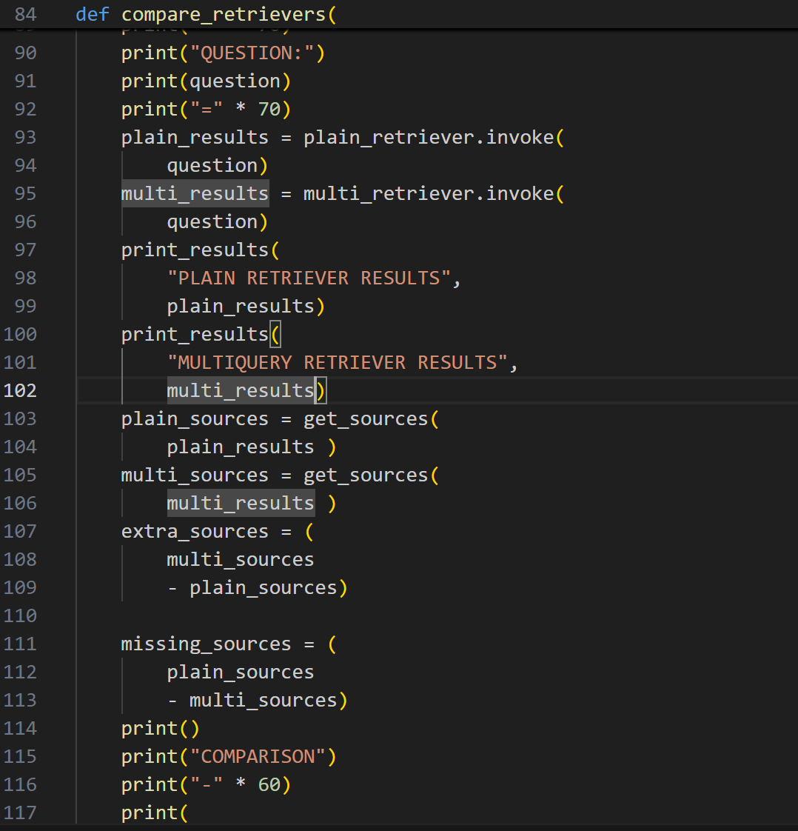
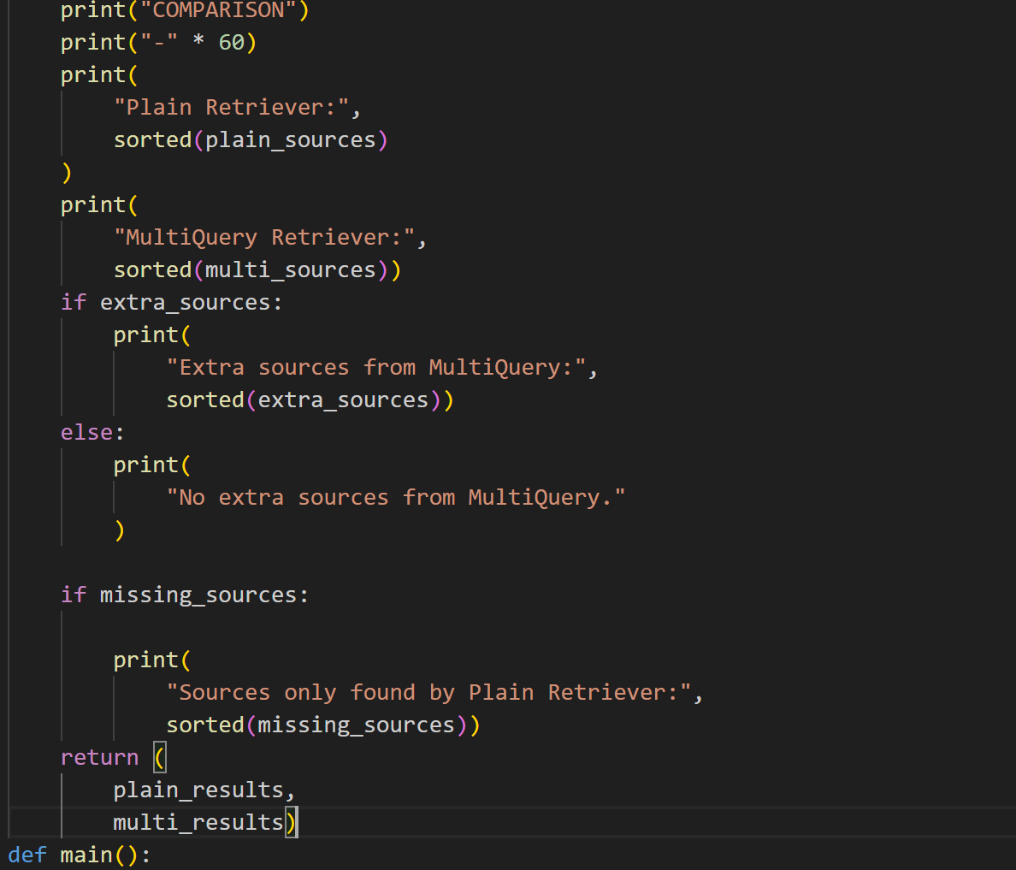
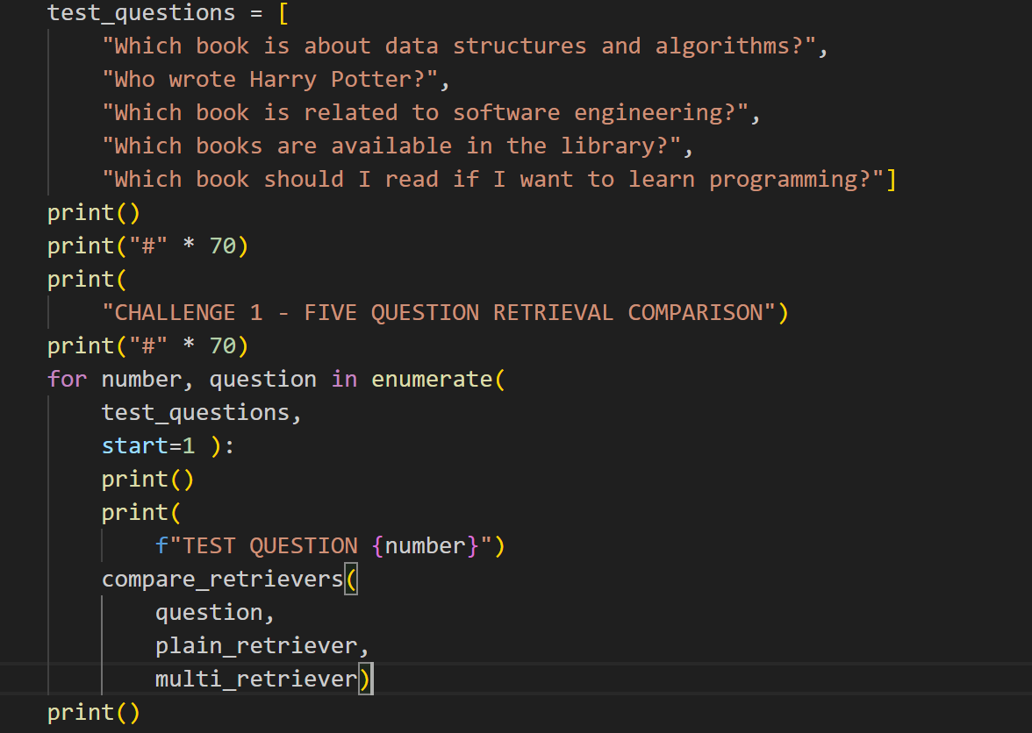
Challenge 2:
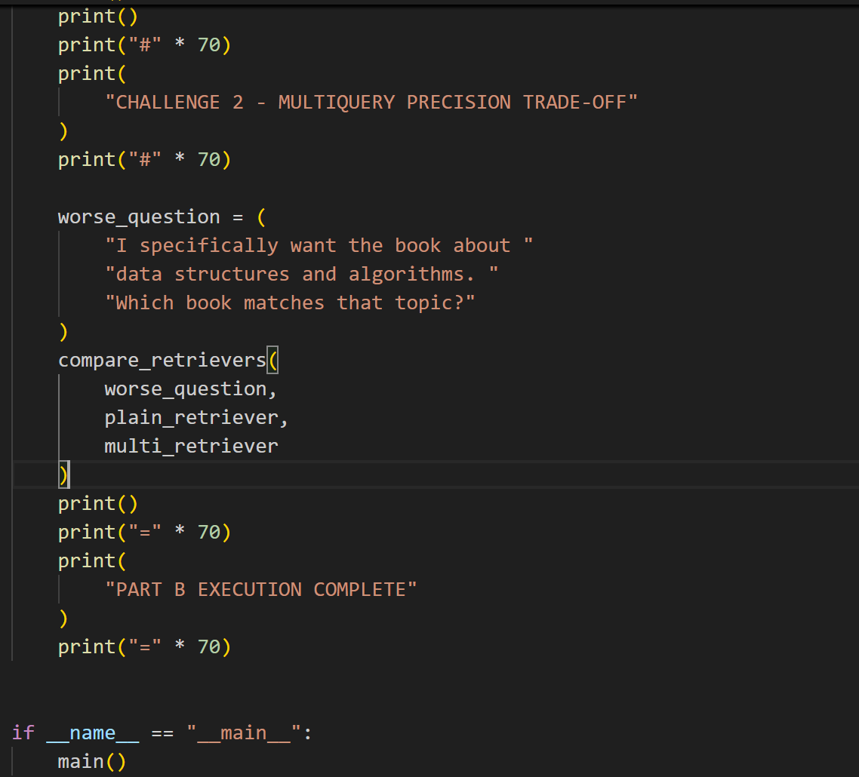
Output:
Challenge 1 output:
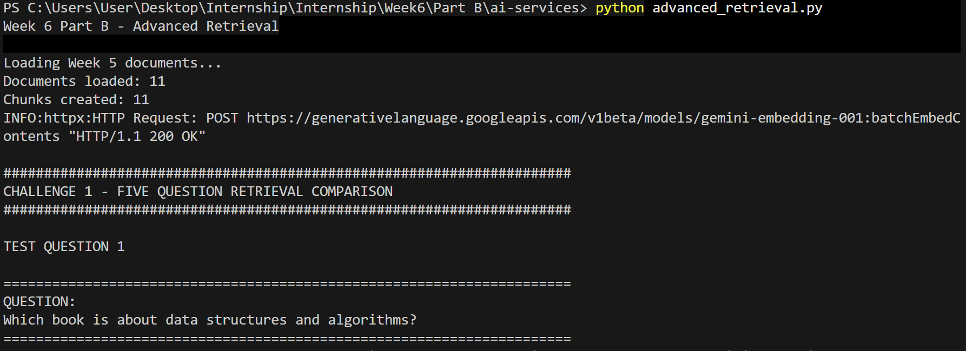
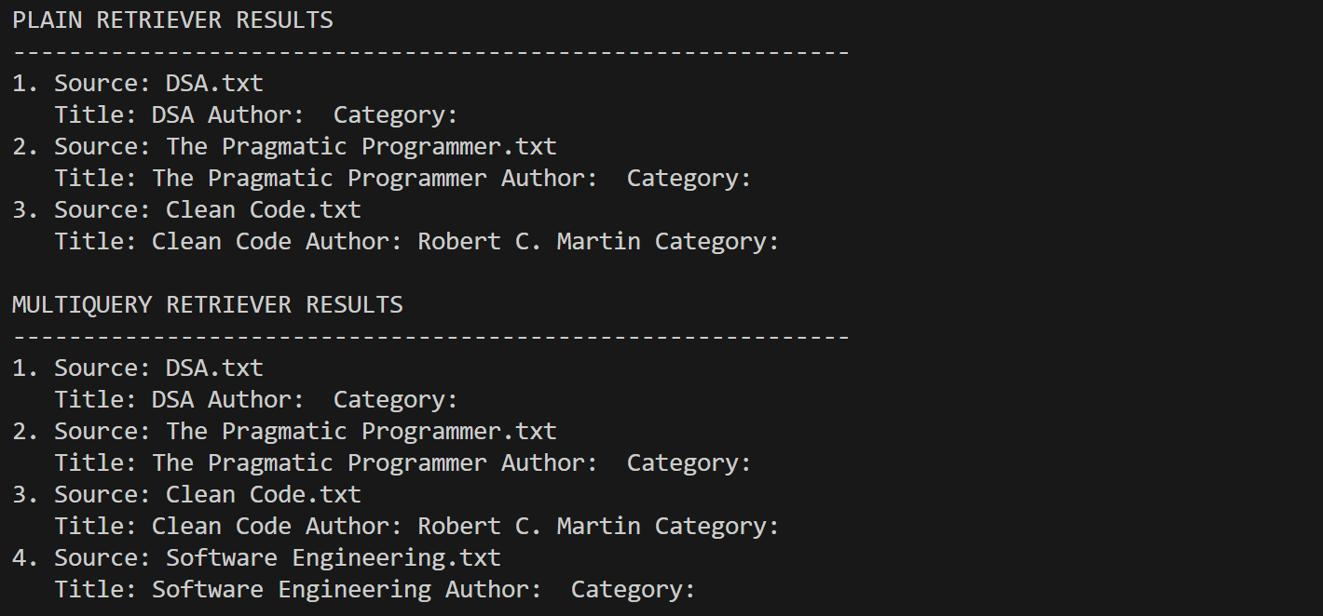
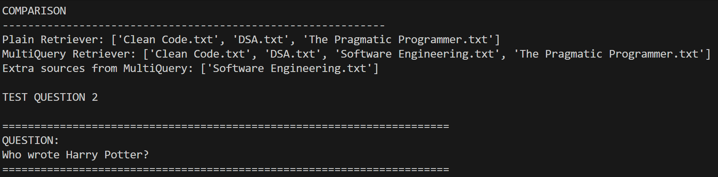
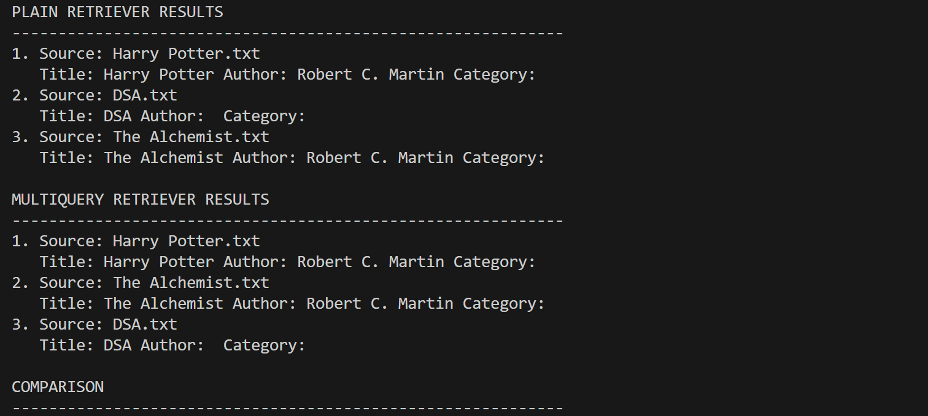
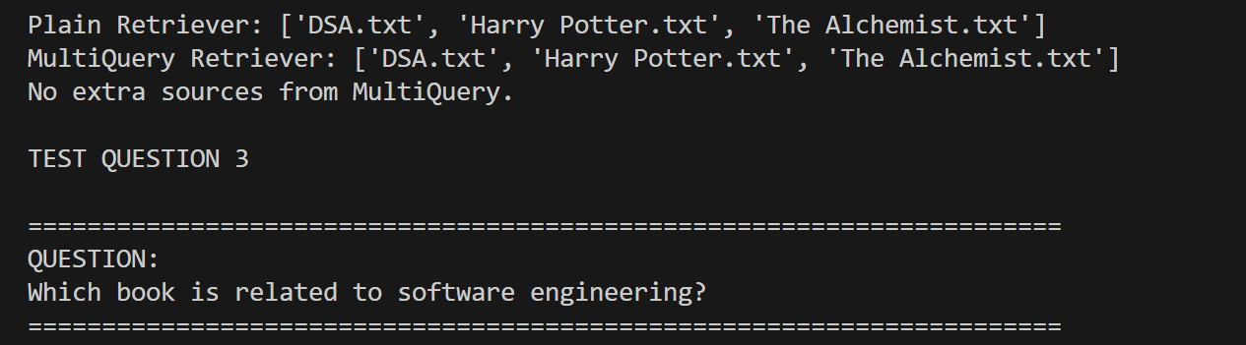
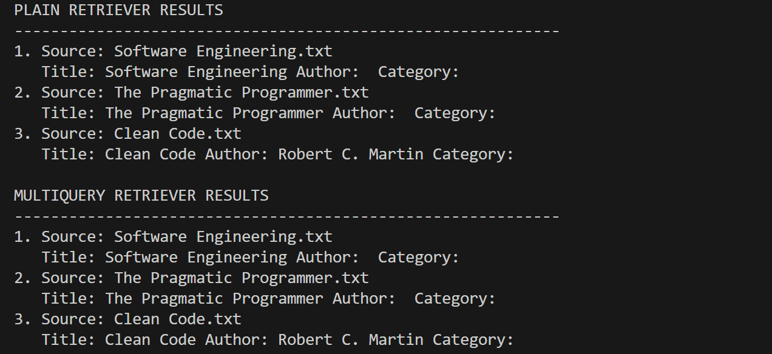
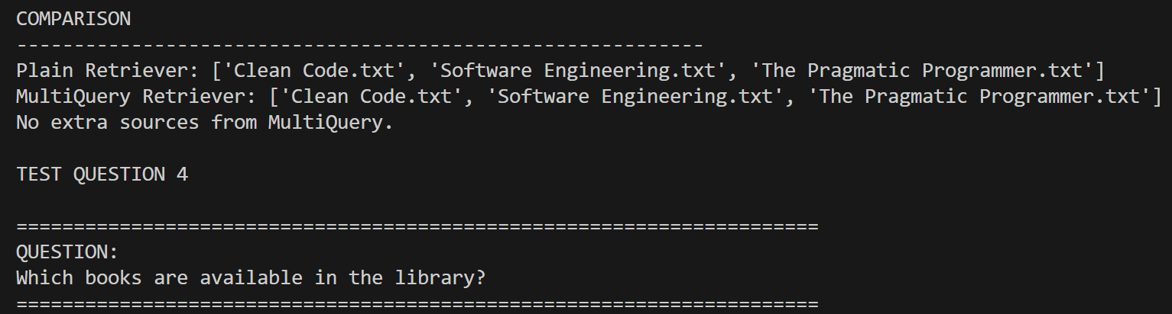
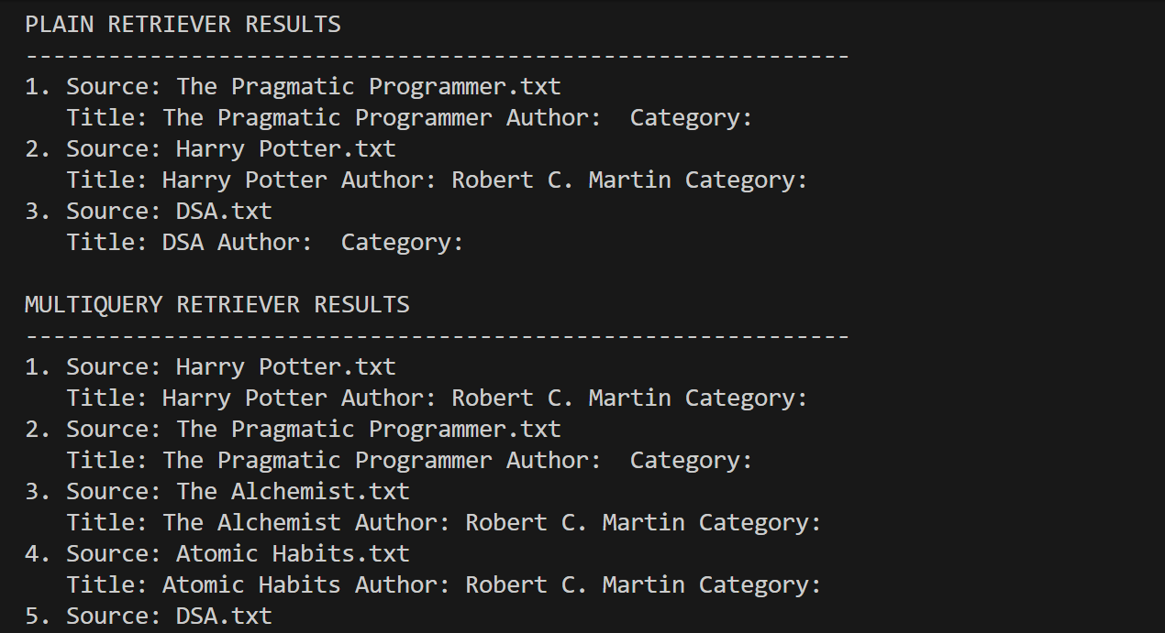
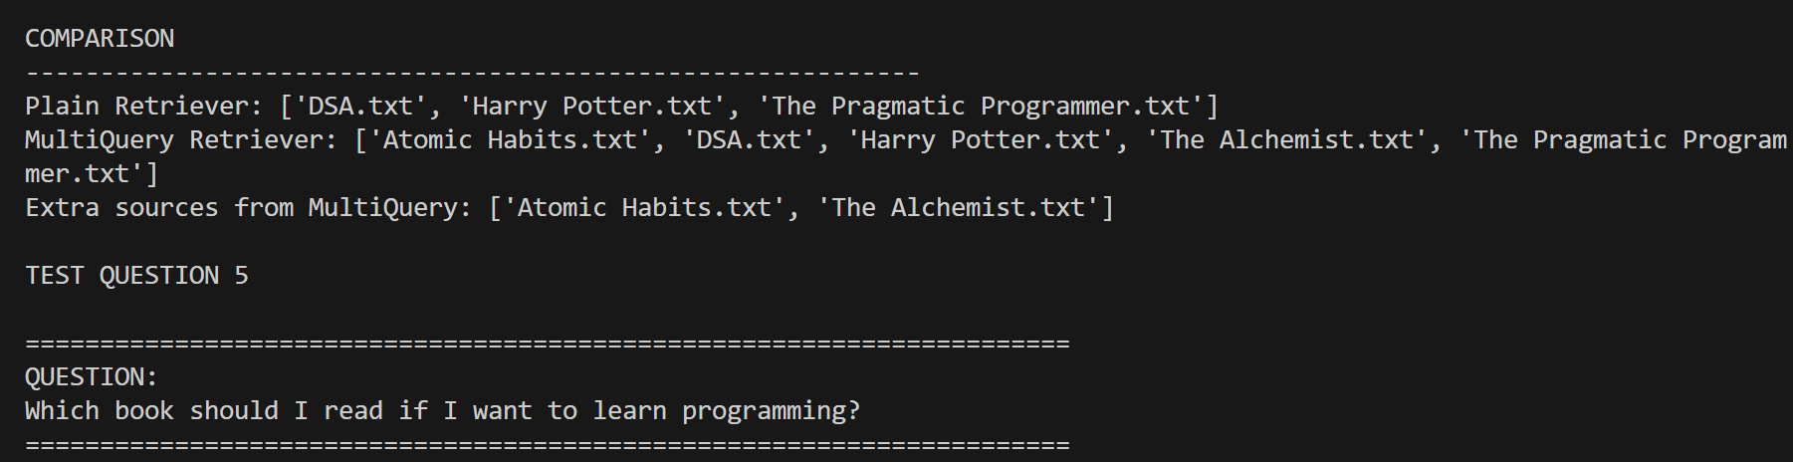
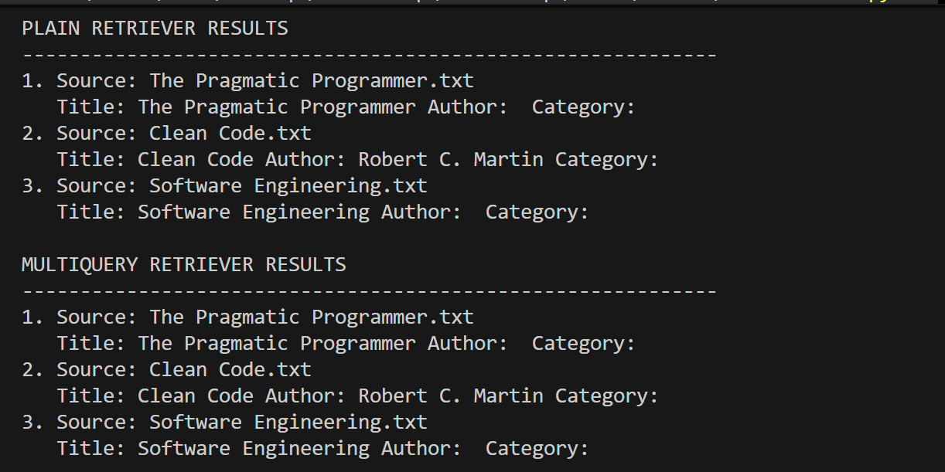
Challenge 2 output:
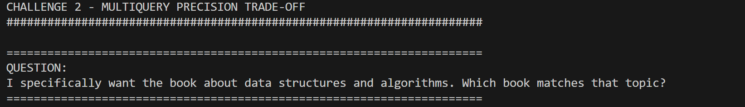
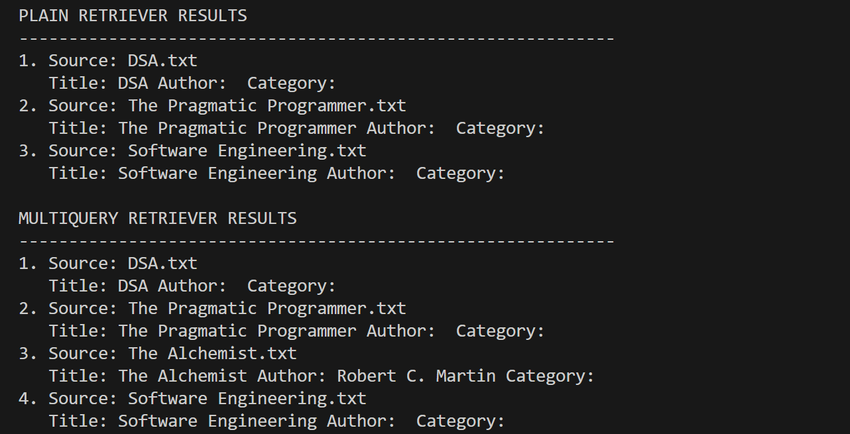
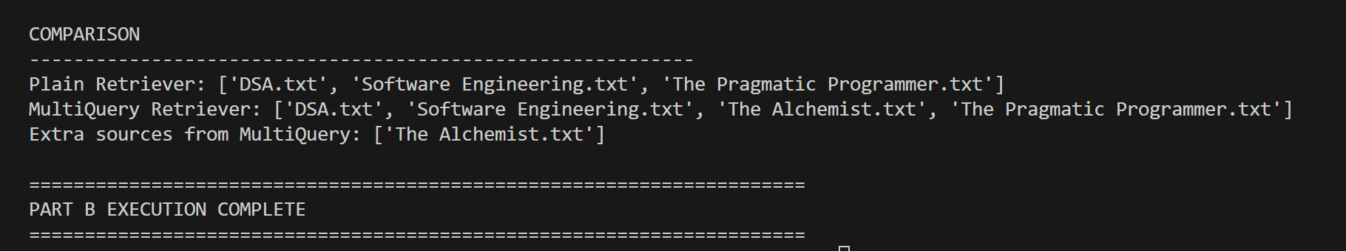
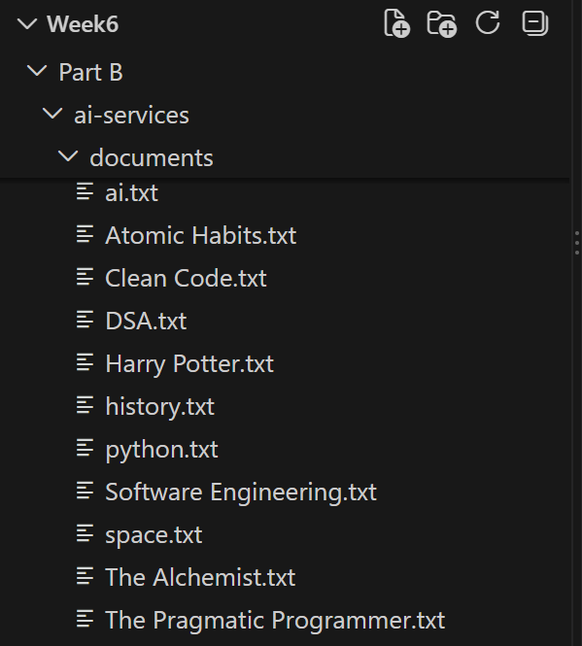

PART C — STRUCTURED OUTPUT & CONVERSATION MEMORY
Challenge:
- Ask a follow-up question that only makes sense with memory ("What genre is it?" right after asking about a specific book) and confirm the session-scoped chain answers correctly while a fresh session (new session_id) does not have that context.
- Combine structured output AND memory in the same chain — this requires understanding how LCEL composes wrapped Runnables, and is not a simple copy-paste of the two snippets above.
Code:
Challenge 1:
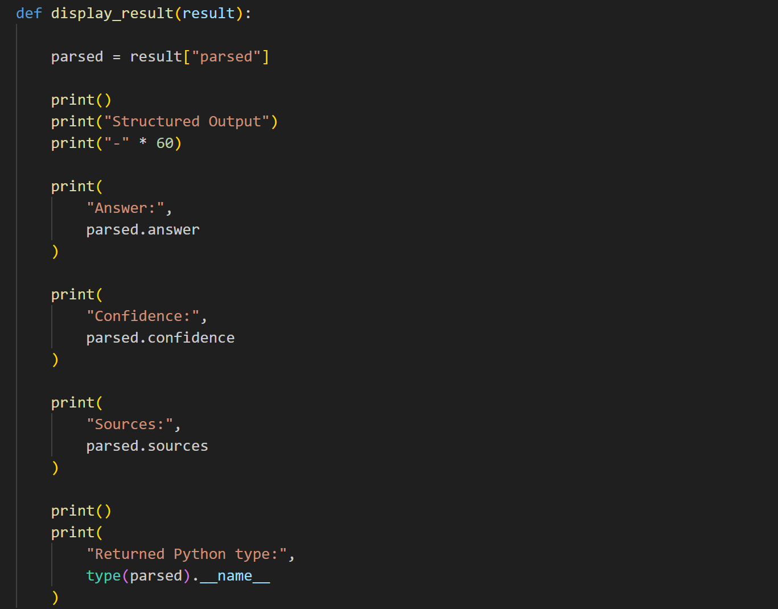
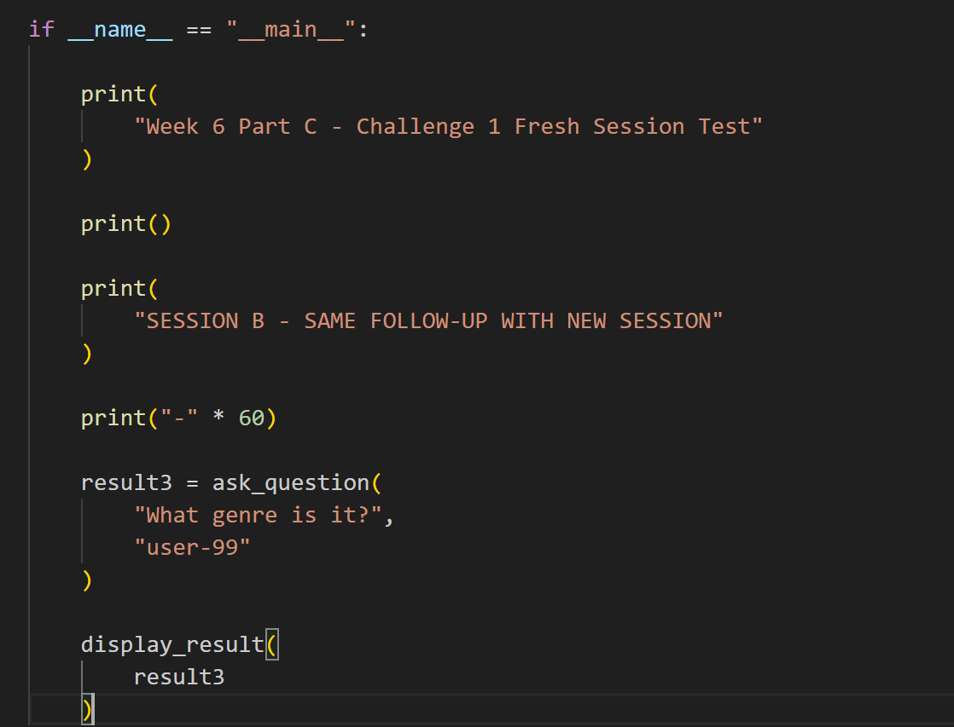
Challenge 2:
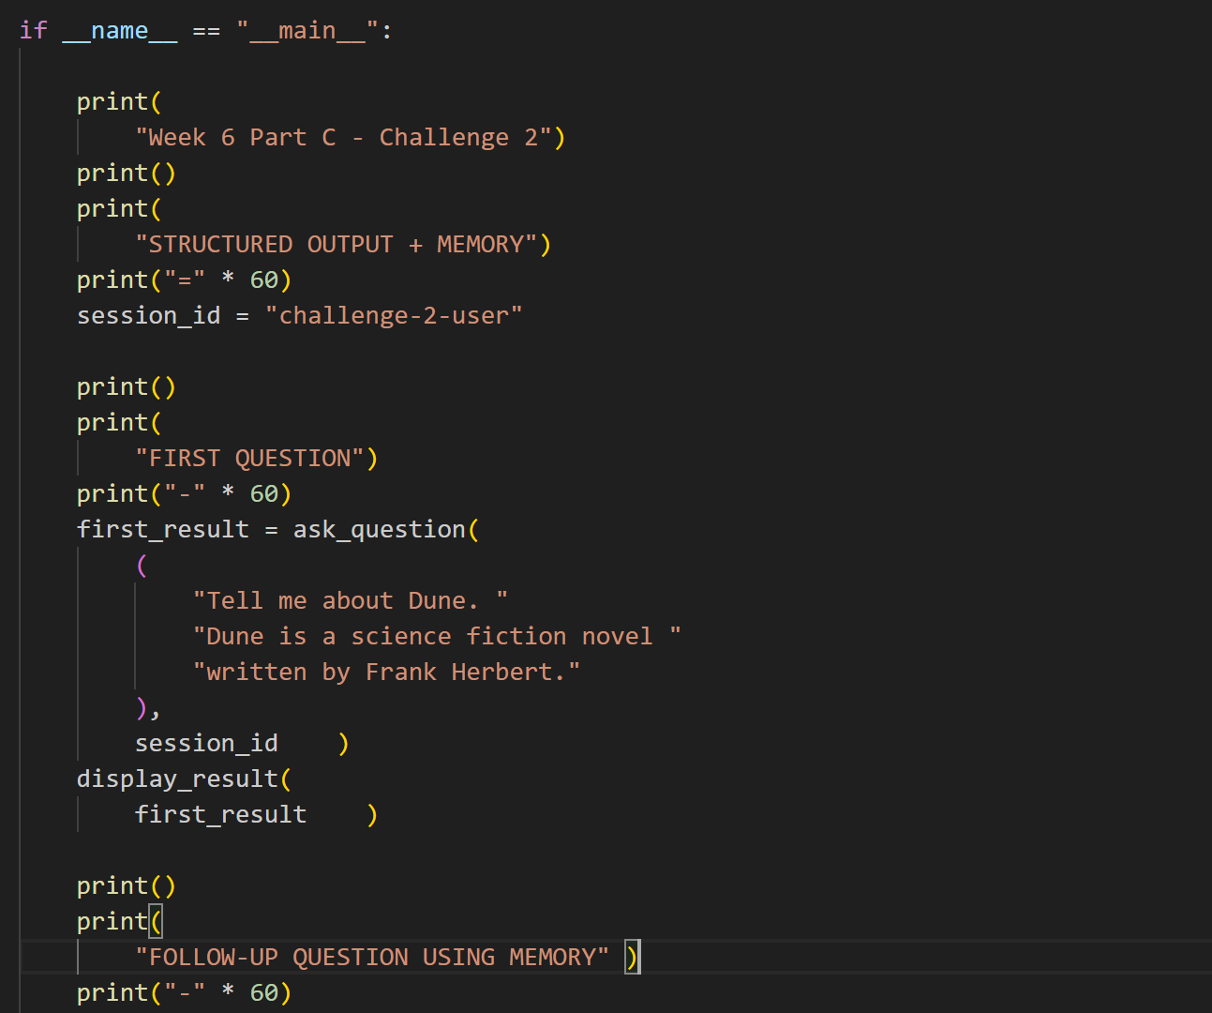
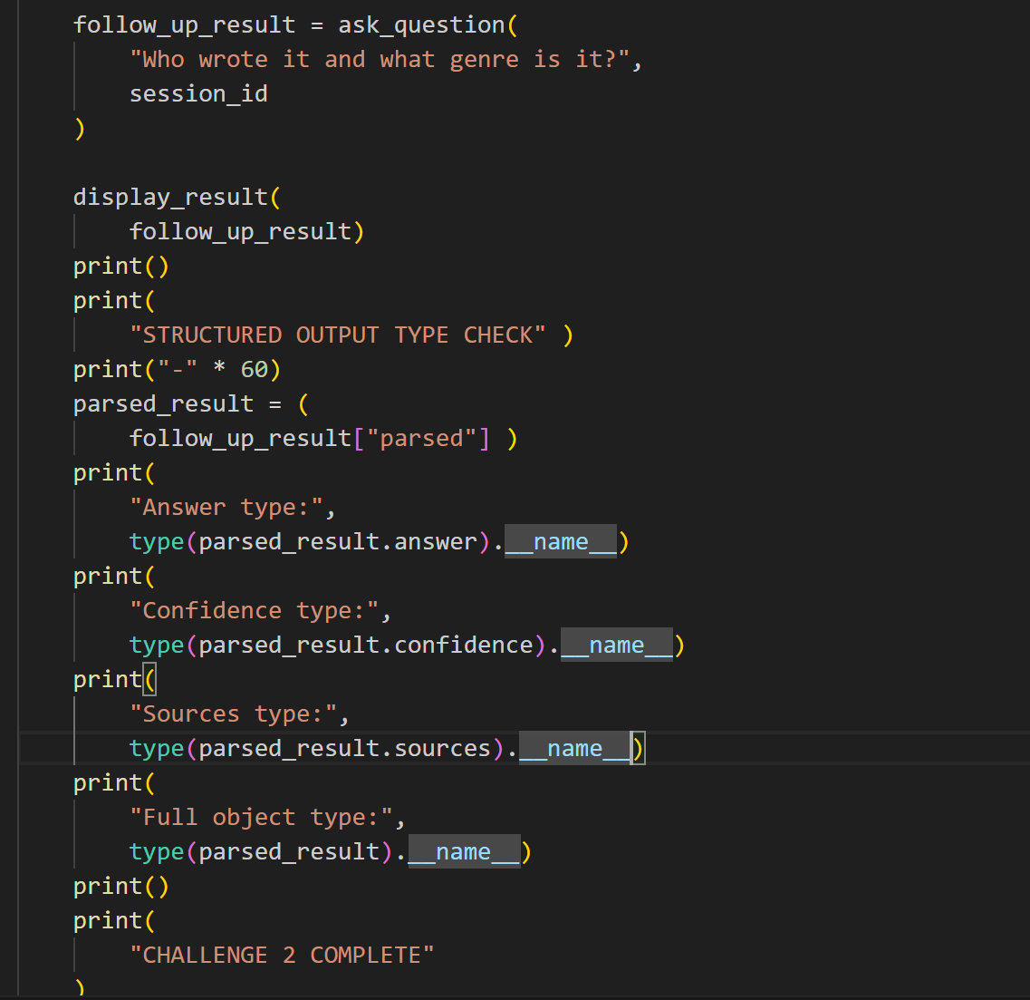
Output:
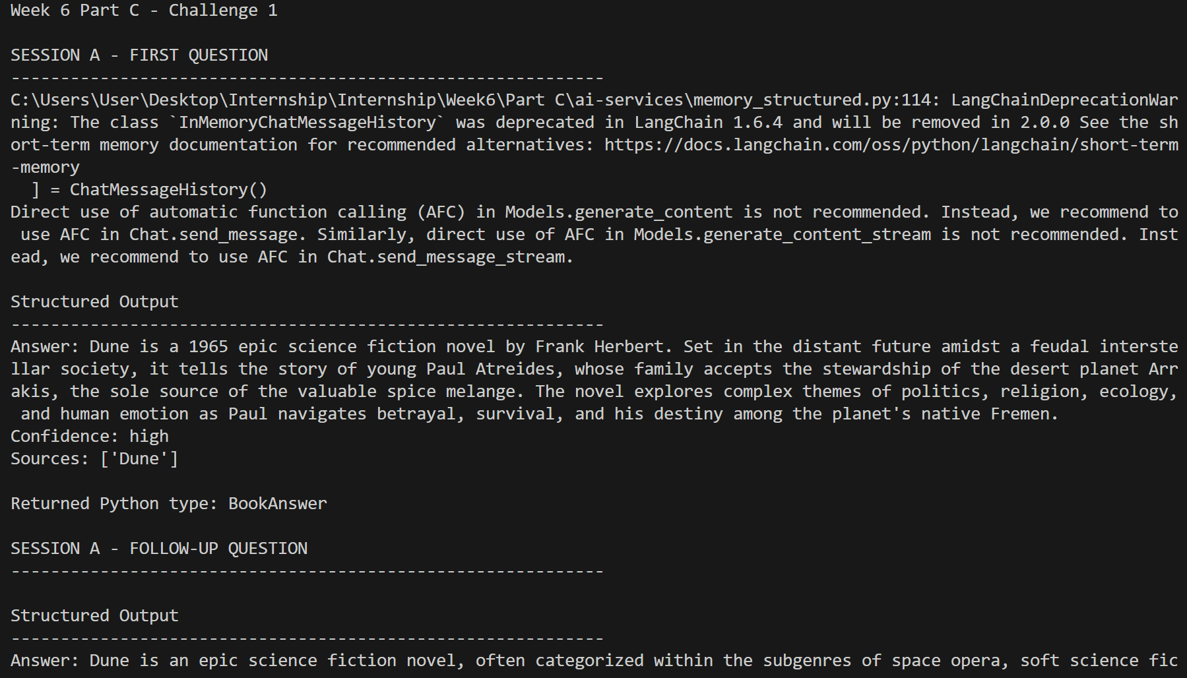
PART D — TOOL CALLING WITH LANGCHAIN
Practice:
- Add the /availability endpoint to the .NET API (a simple boolean field on the Book entity is enough — add it via a new migration).
- Ask the model a question that should trigger the tool ("Is book 4 available?") and one that shouldn't ("What genre is book 4?") and confirm the model only calls the tool when it's actually needed.
- Feed the tool's result back into the model as a follow-up message and get it to phrase a natural-language answer using that result, instead of just printing the raw tool output.
Code:
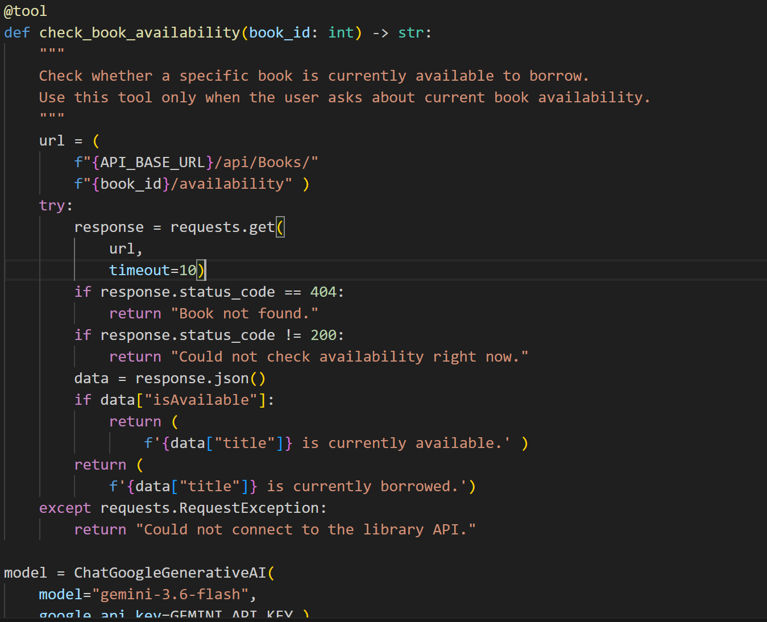
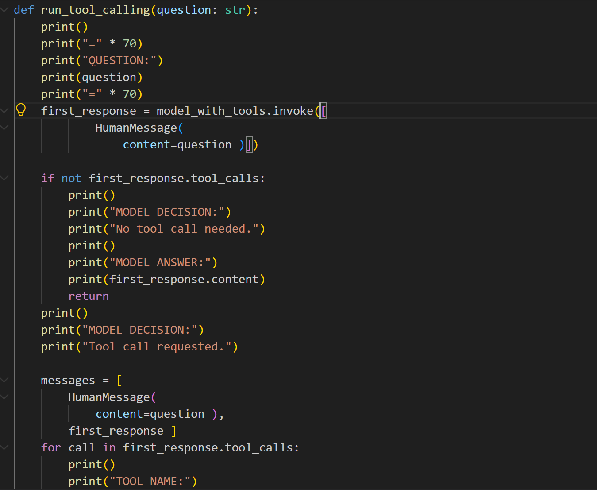
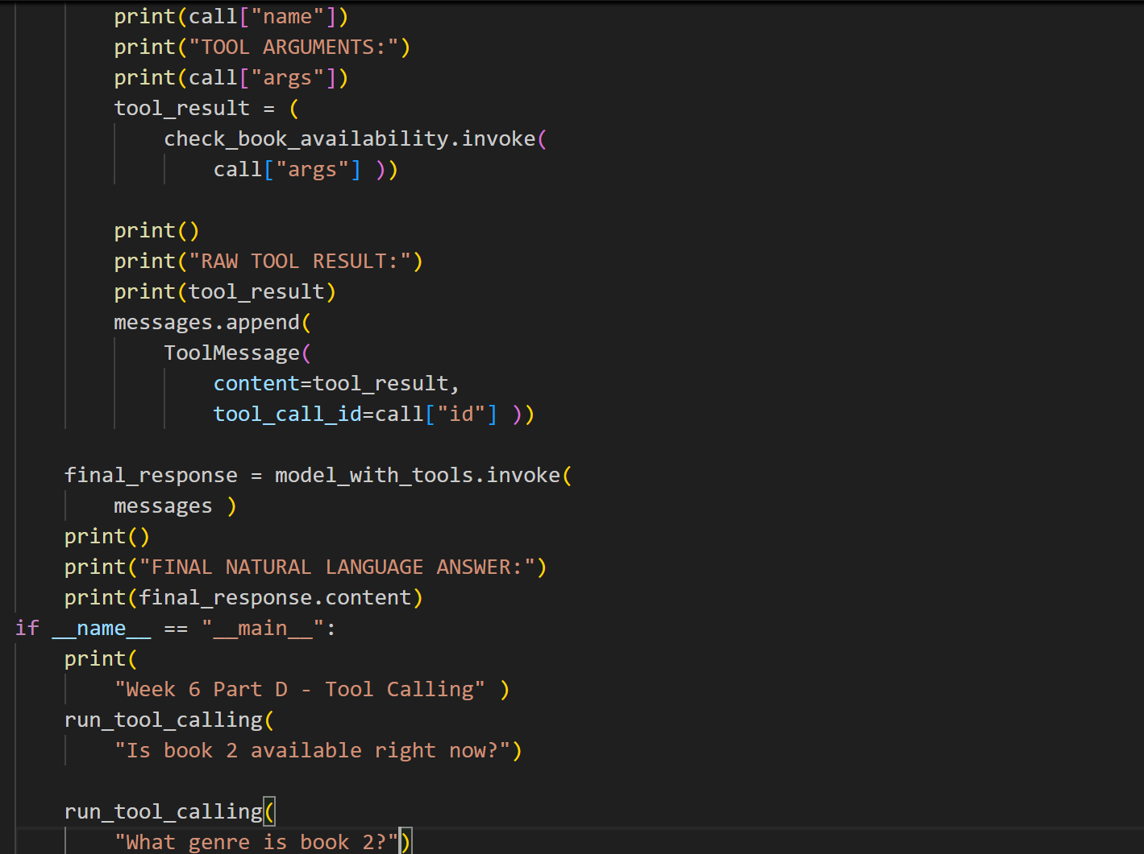
Output:
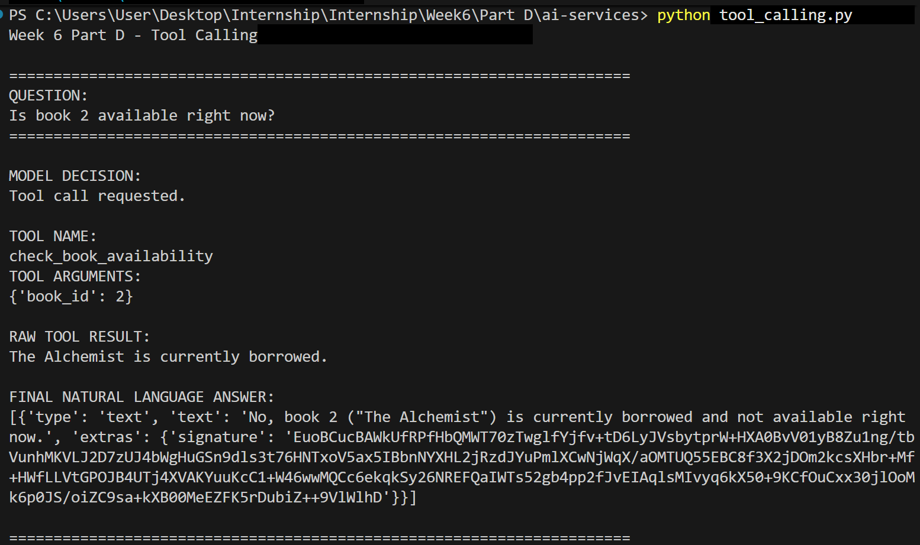
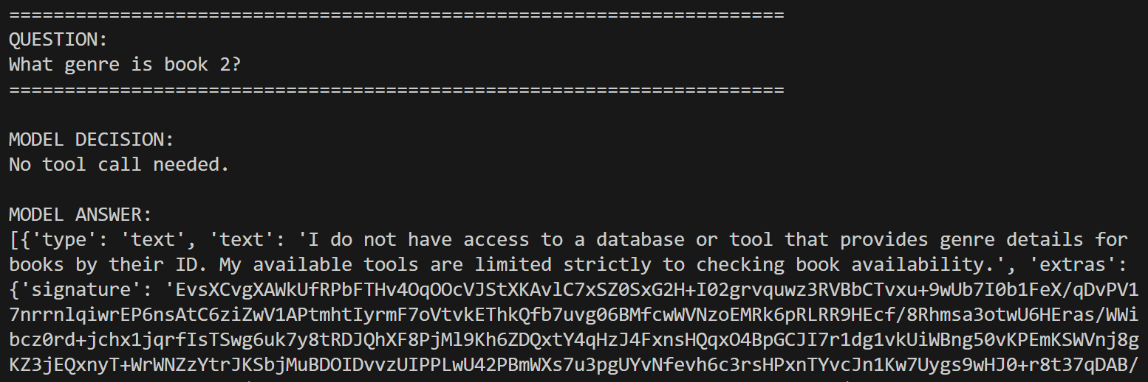
PART E — RESILIENT .NET fi AI SERVICE INTEGRATION (PRODUCTION-GRADE)
Challenge
- Deliberately stop the FastAPI service and call the new .NET endpoint 4–5 times in a row. Confirm you see: retries happening (check logs/timing), then the circuit opening, then a fast 503 instead of a slow timeout on later attempts.
- Explain, in writing, why retrying immediately without backoff would make an already-struggling AI service worse, not better.
- Explain, in writing, what would go wrong if the retry policy retried a request that had already partially succeeded on the AI service side (e.g. it had already started generating a paid API call) — this is why not every failure should automatically be retried, only "transient" ones.
Code:
Program.cs:
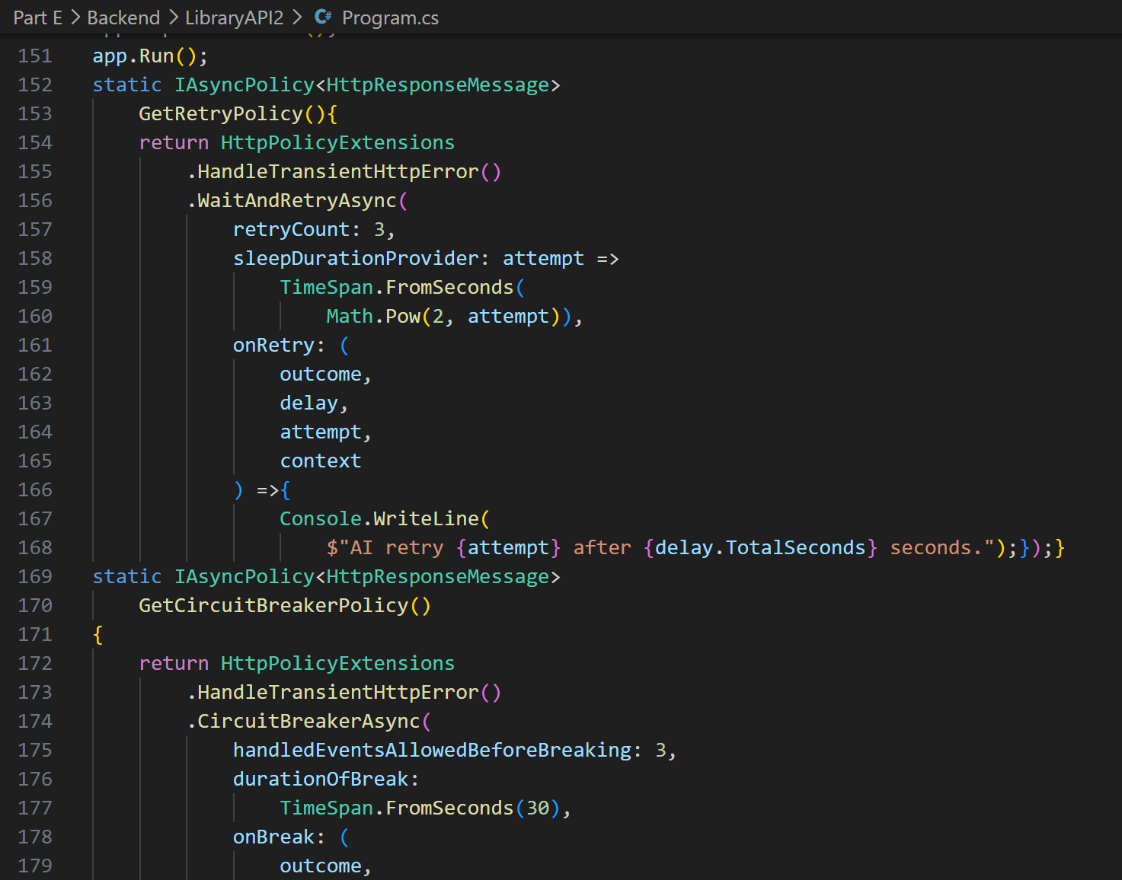
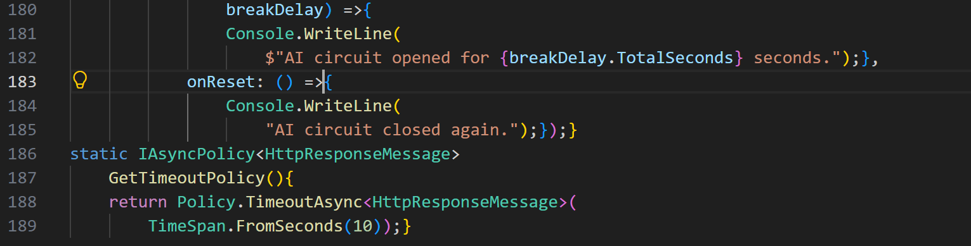
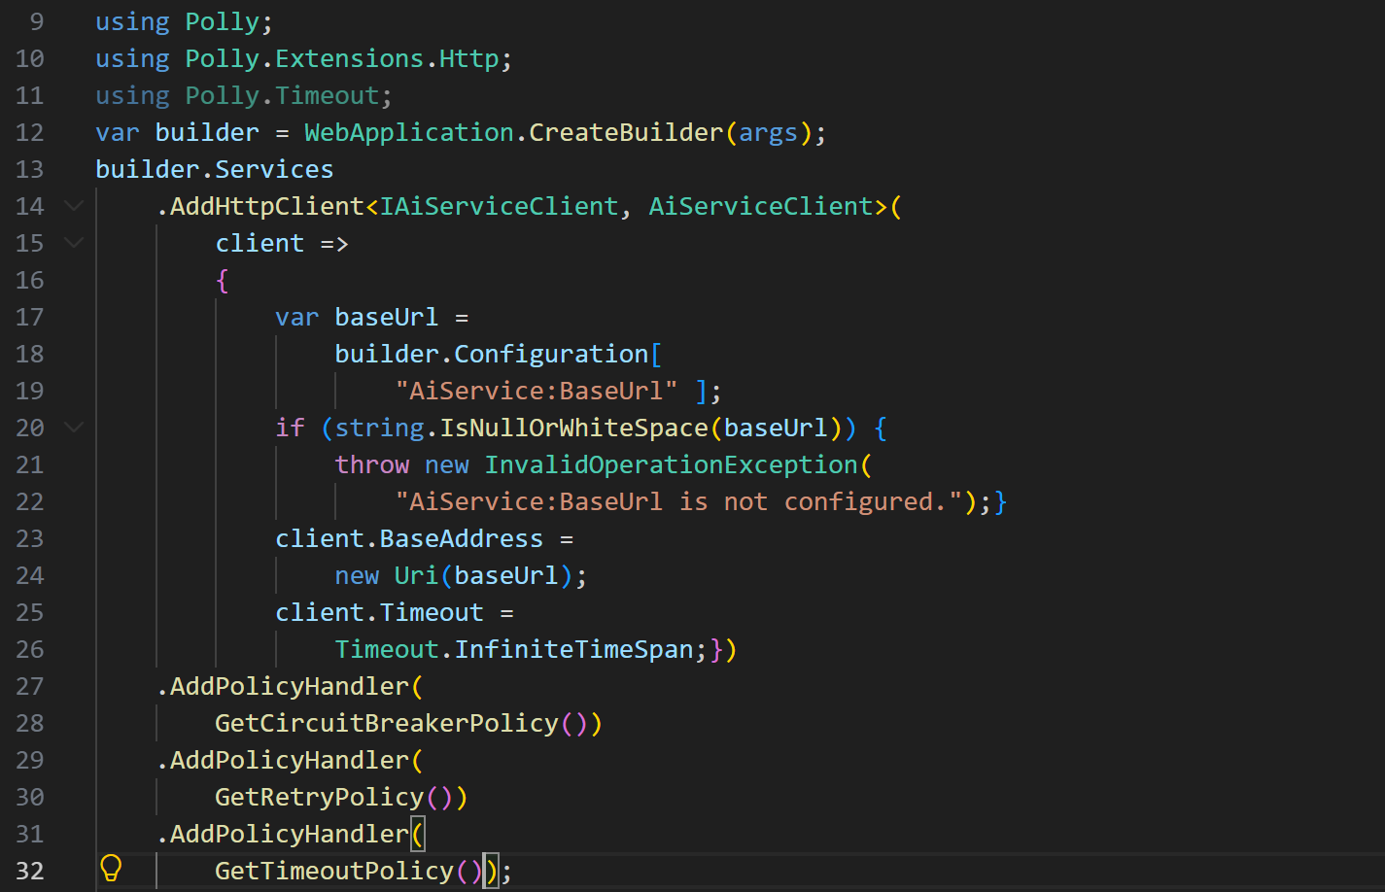
Assistant Controller.cs:
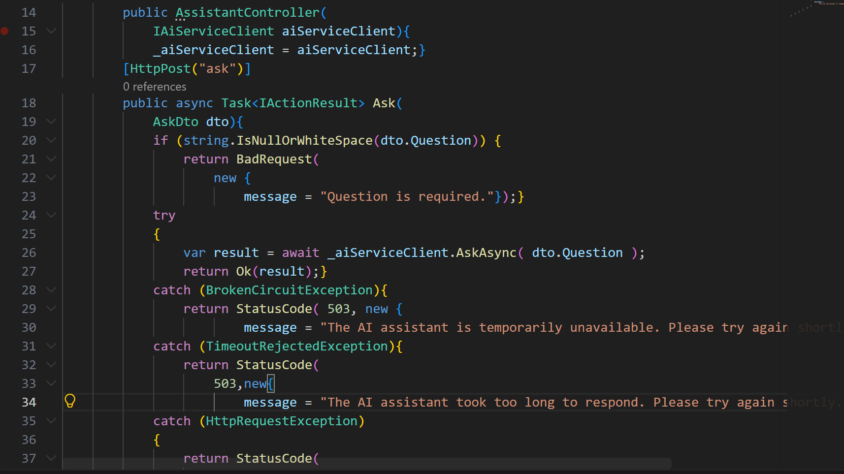
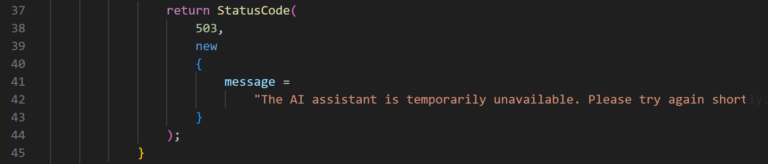
Output:
Challenge 1 — Retry + Circuit Breaker + 503:
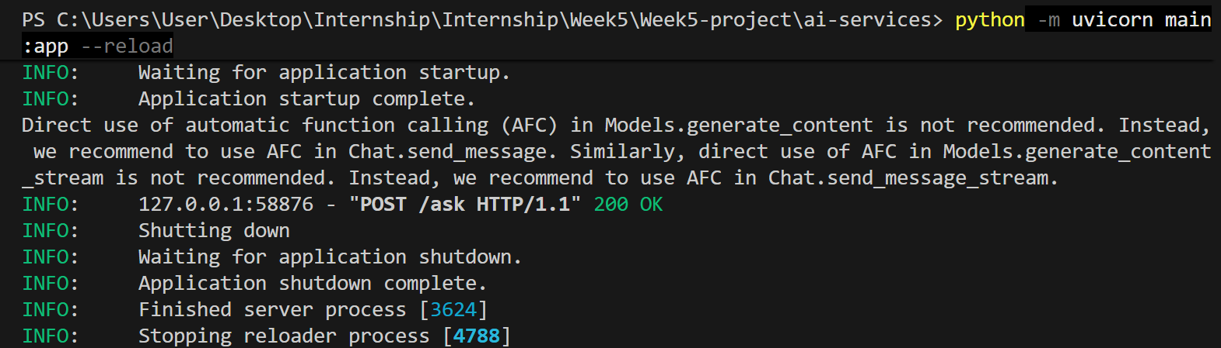
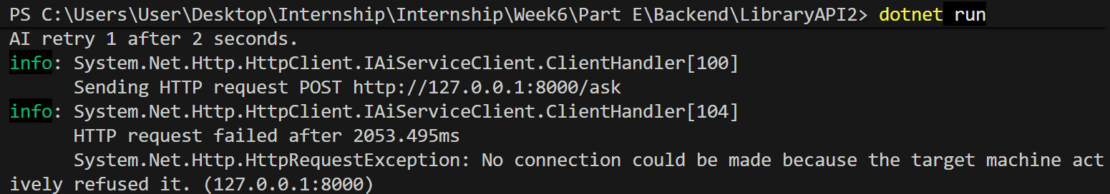
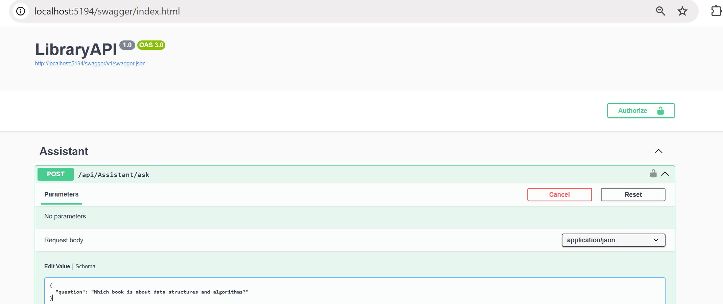
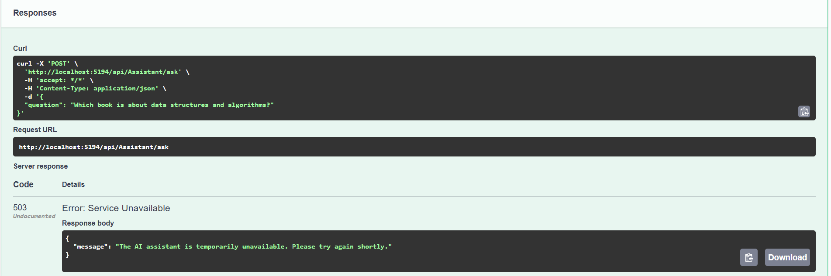
PART F — END-TO-END STREAMING (FASTAPI fi .NET fi ANGULAR)
Challenge
- Get a visible token-by-token render working in a simple chat UI — text should visibly grow as it arrives, not appear all at once at the end.
- Deliberately introduce a delay in the FastAPI generator (e.g. time.sleep(0.3) between chunks) and confirm you can actually see it streaming — this proves it's real streaming and not an illusion caused by a fast connection. • Remove the FlushAsync() call in the .NET proxy, observe what breaks (the response likely buffers and arrives all at once instead of live), then put it back and explain why it mattered.
- Handle the case where the user navigates away mid-stream — cancel the upstream request instead of leaving it running in the background.
Code:
Challenge 1:

Challenge 2:
Main.py:
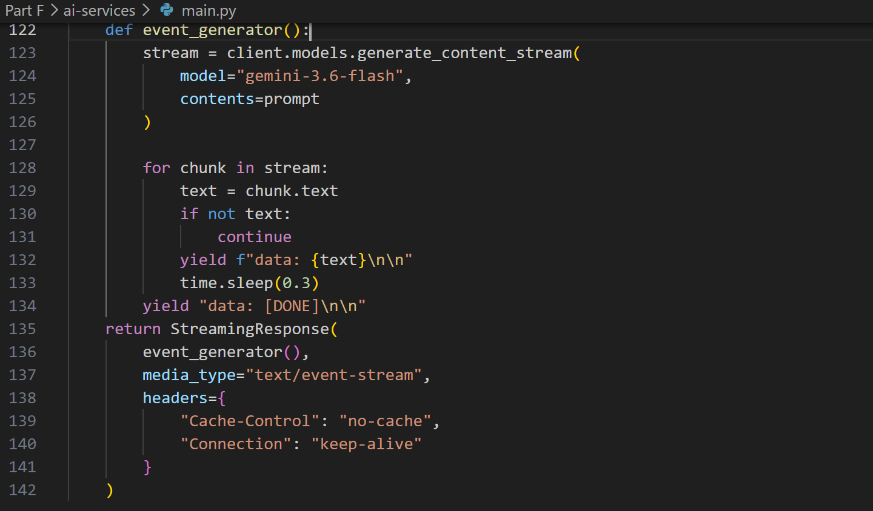
Challenge 3:
AssistantController.cs:
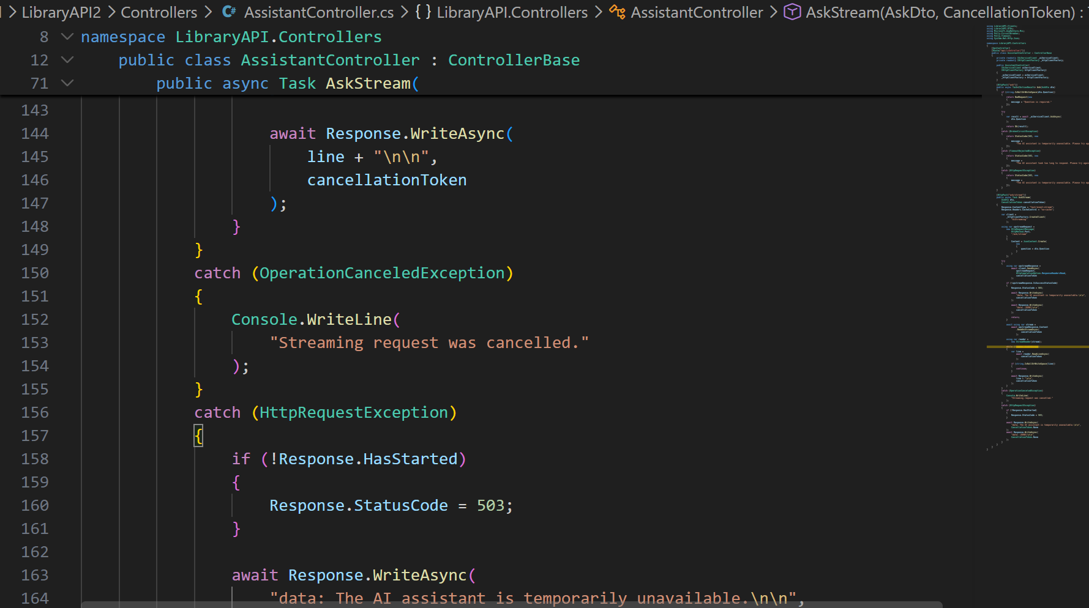
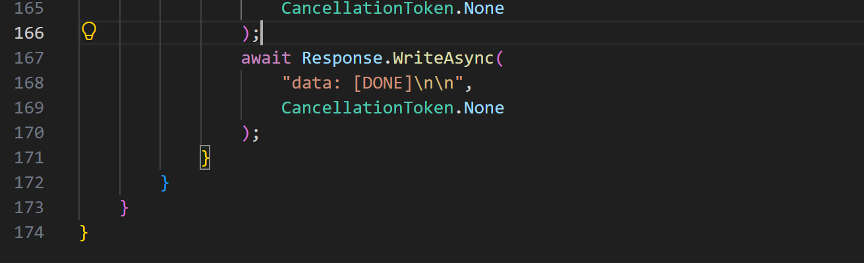
Challenge 4:

Output:
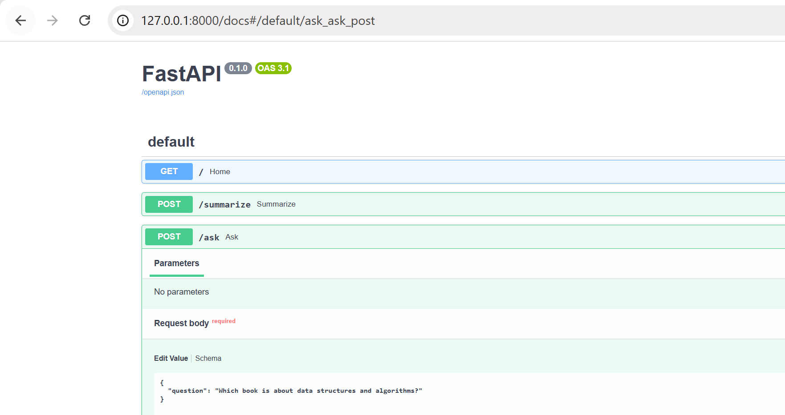
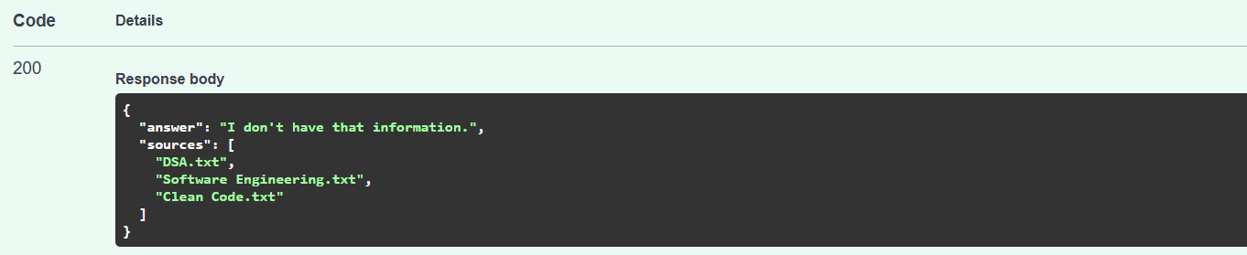
/ask/stream:
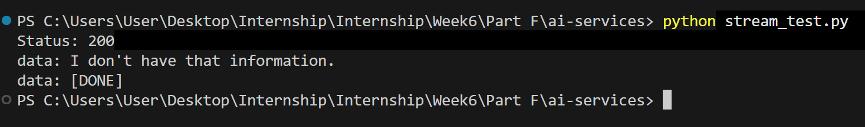
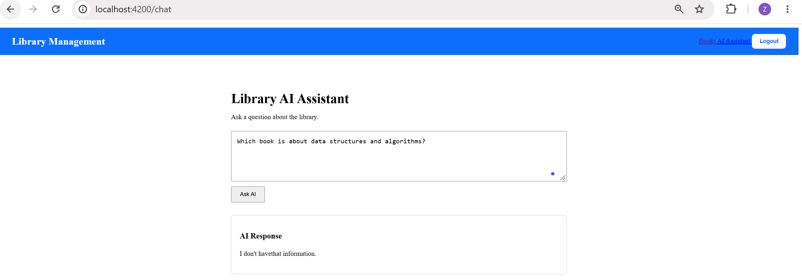
Challenge 1:
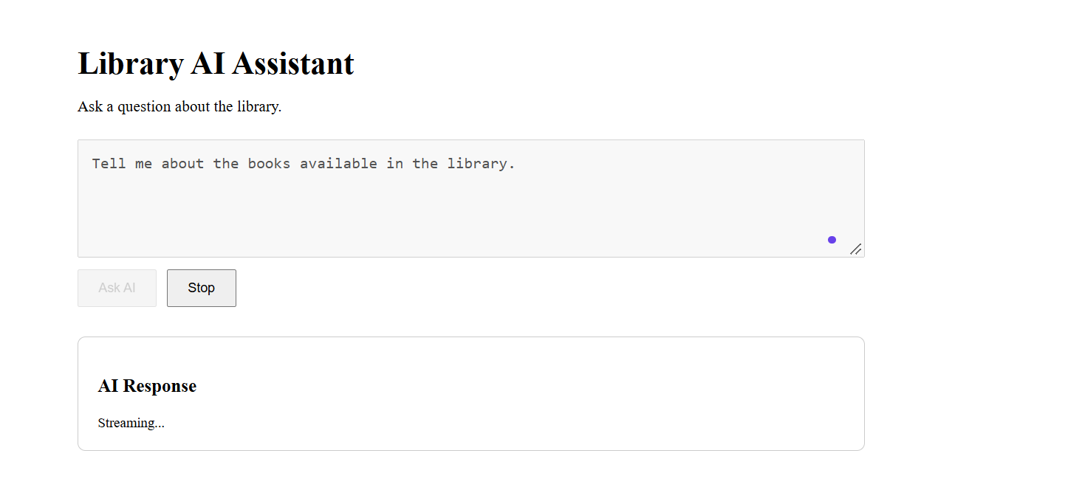
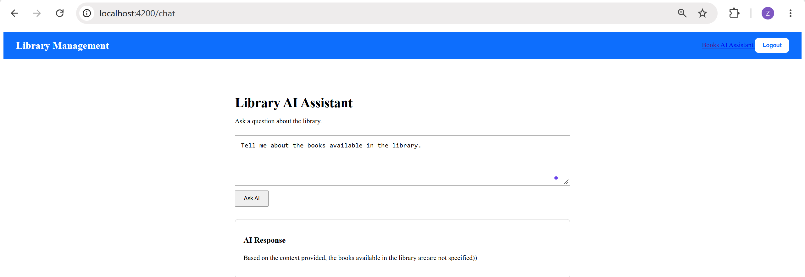
Challenge 2 — Add a delay to prove it is truly streaming:
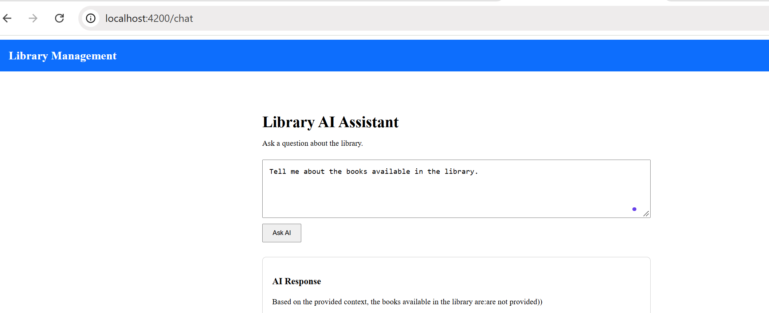
Challenge 3:
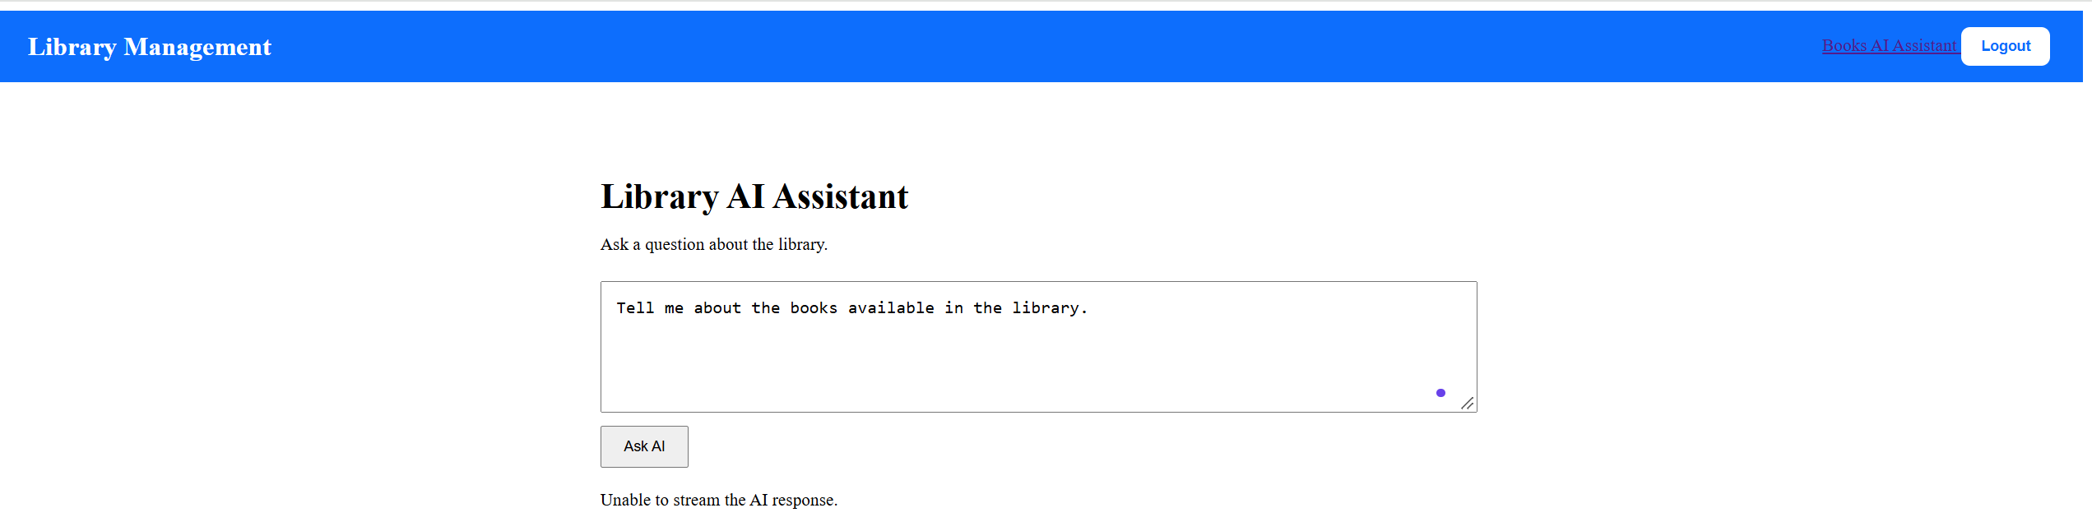
Challenge 4:
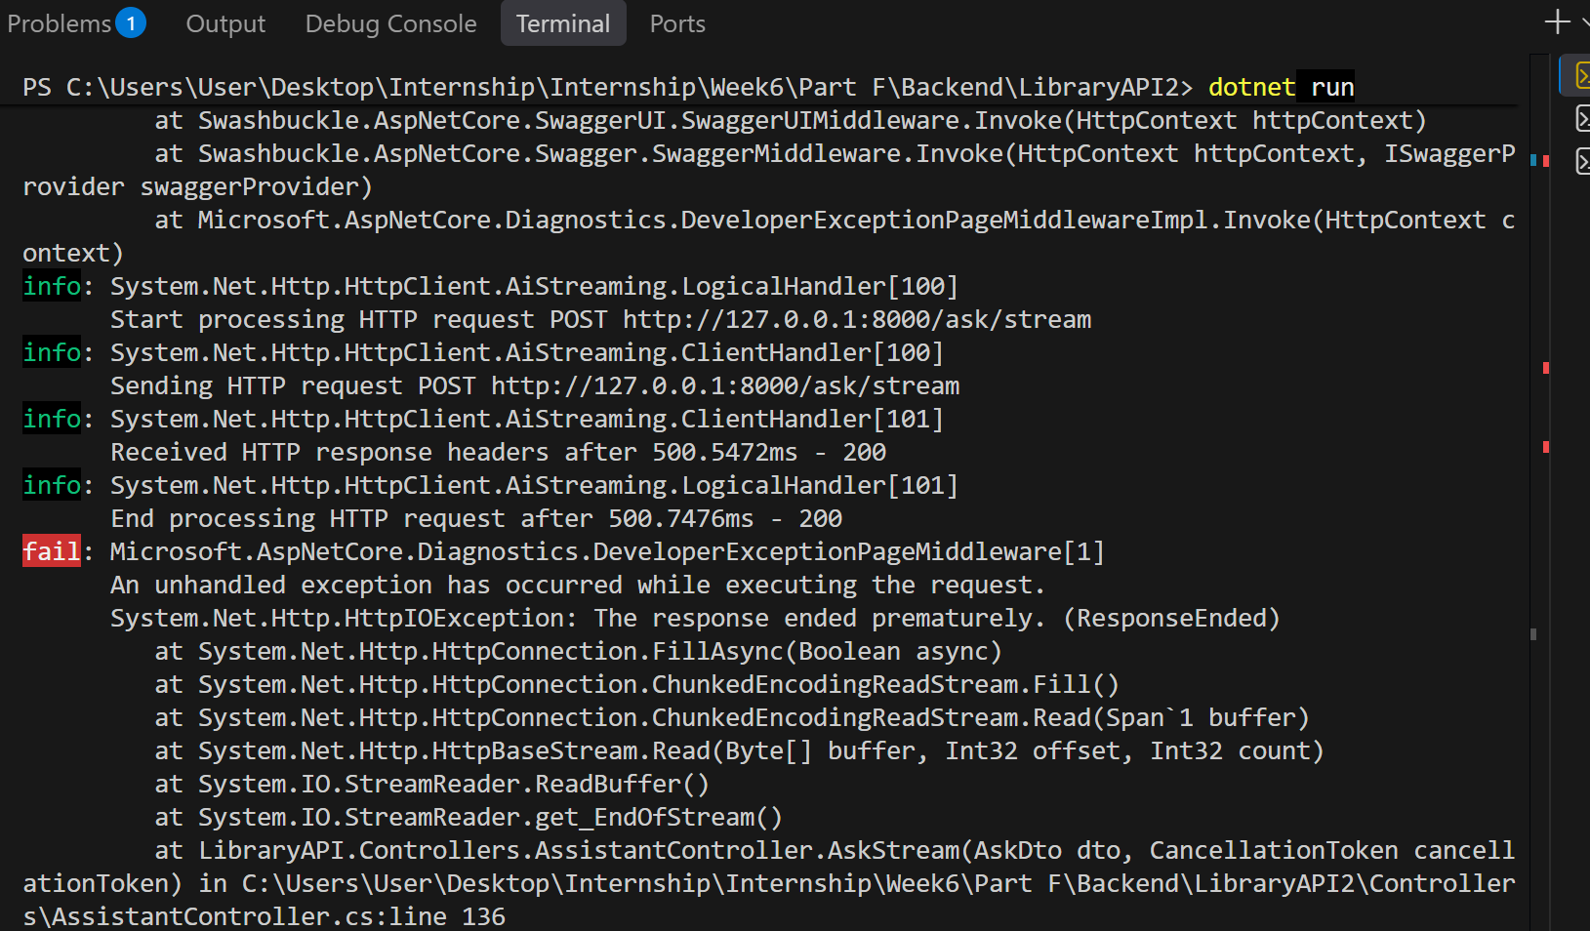
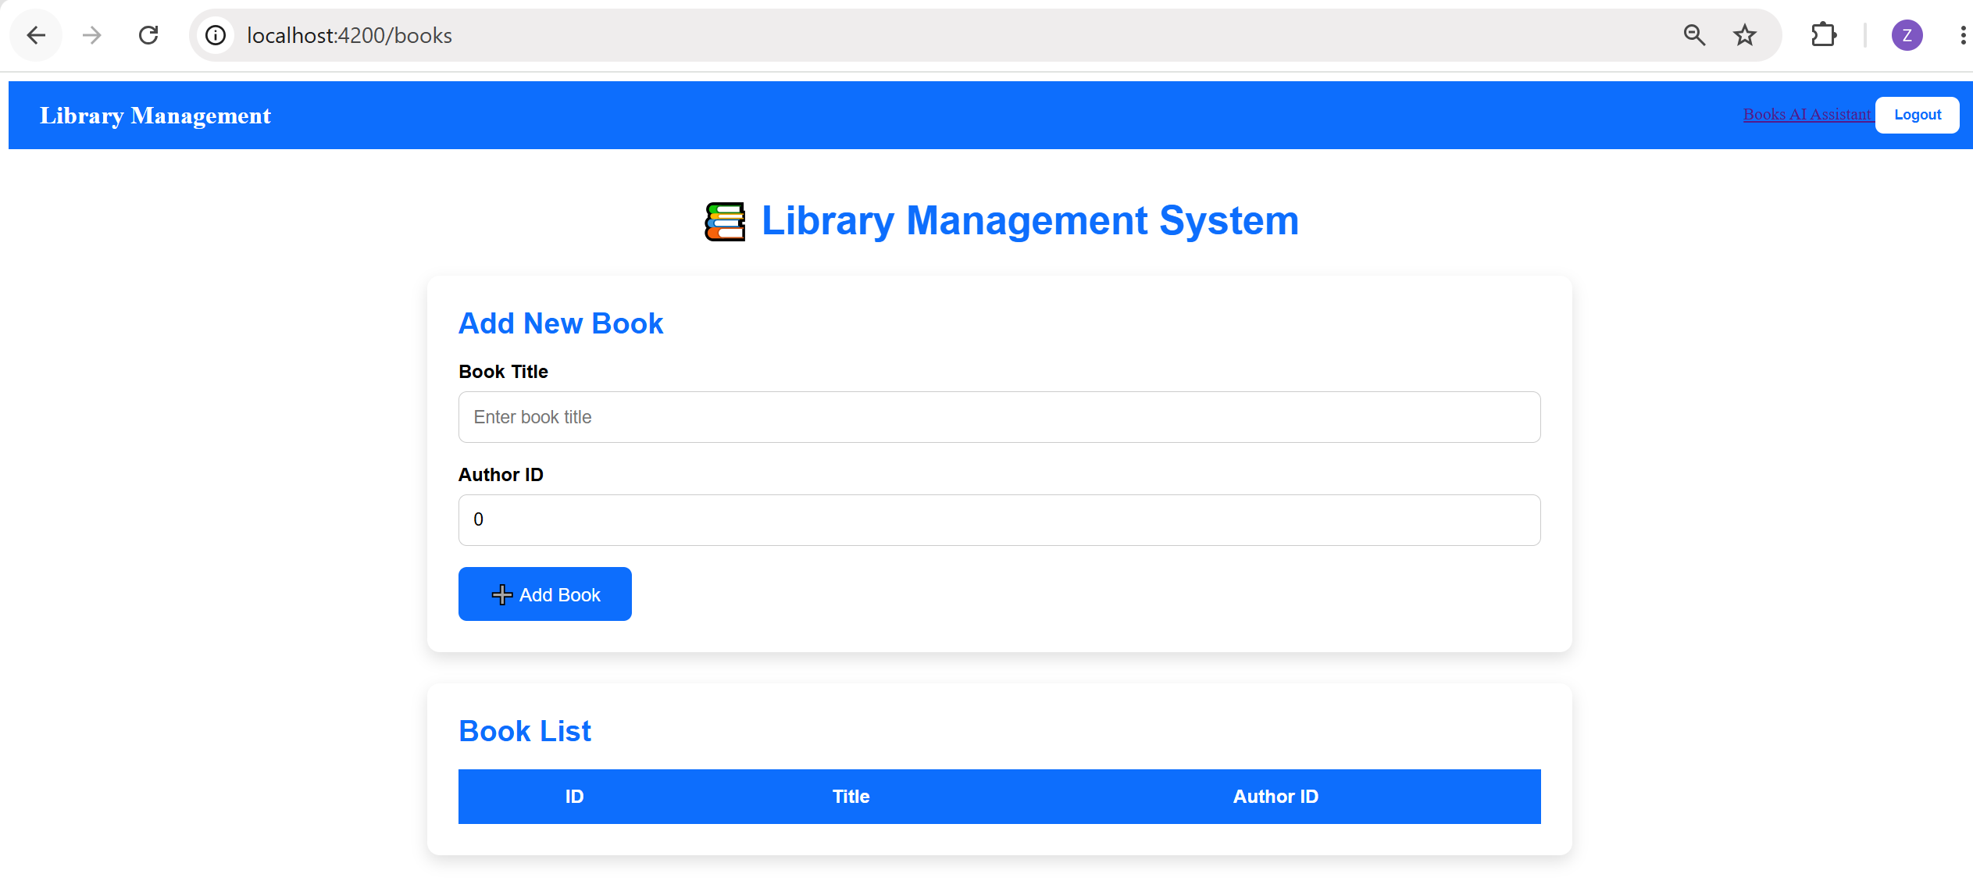

PART G — GIT: CLEANING HISTORY WITH INTERACTIVE REBASE
Practice
- Complete the squash exercise above on a throwaway branch first, to get comfortable before doing it on real project work.
- Apply it for real on at least one of this week's feature branches before opening its Pull Request
Output:
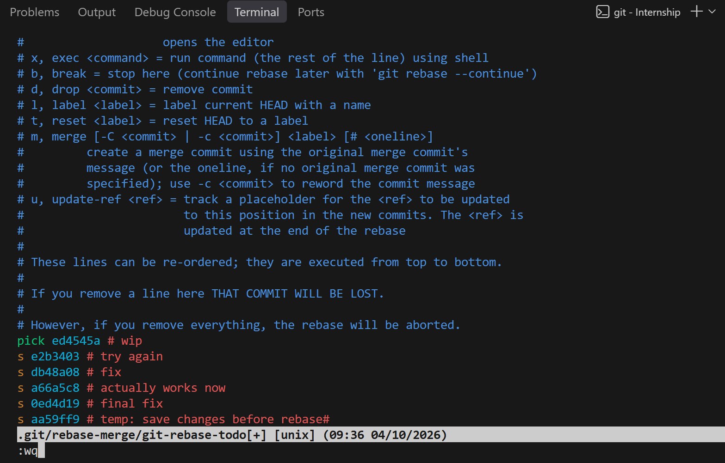
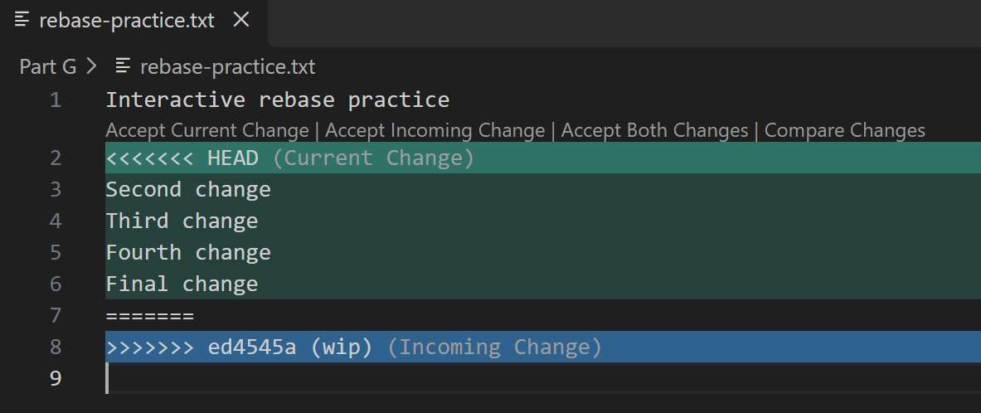
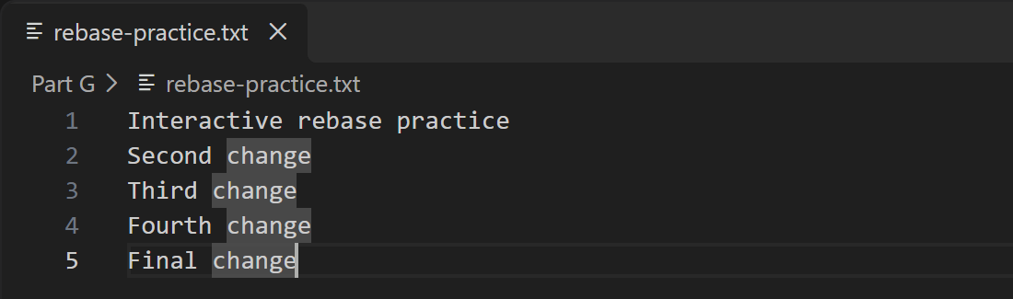
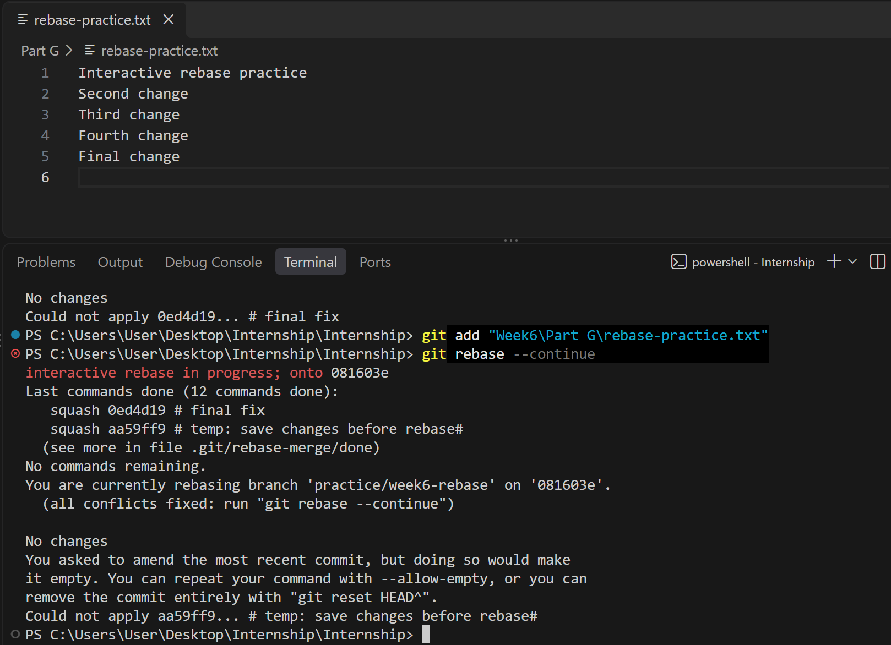
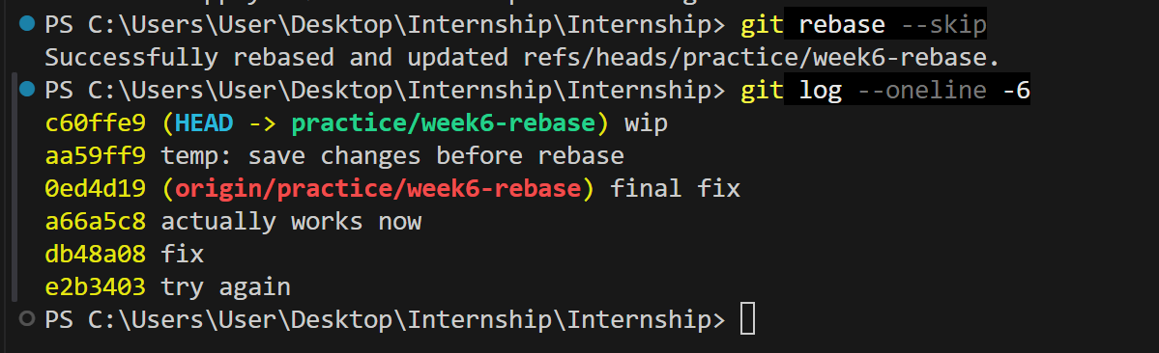
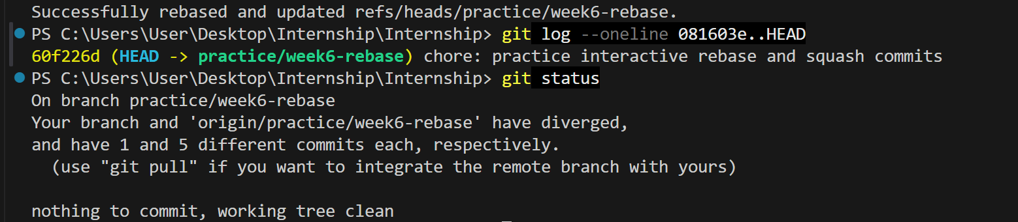
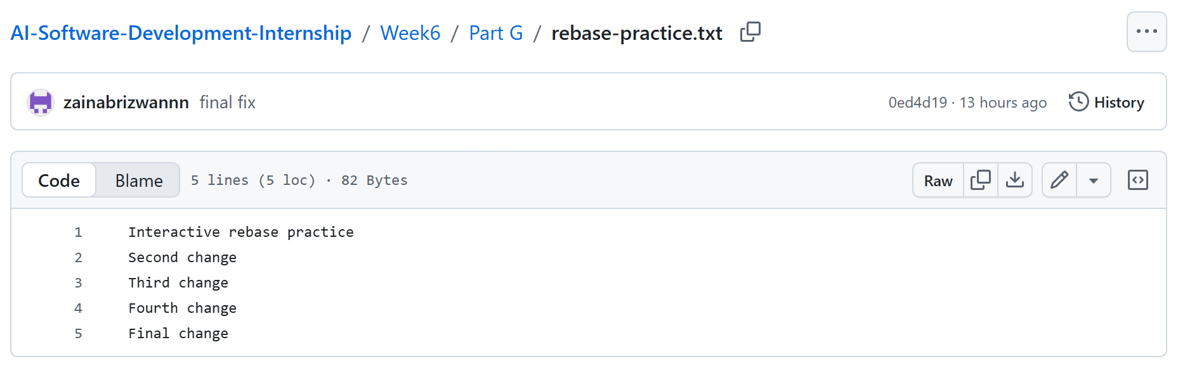
WEEK 6 PROJECT — LIBRARY AI ASSISTANT, FULLY WIRED
- Rebuild the RAG chain in LangChain: LCEL composition, RecursiveCharacterTextSplitter, MultiQueryRetriever, structured output, and session-scoped memory, combining Parts A–C. Branch: feature/langchain-rag-chain.
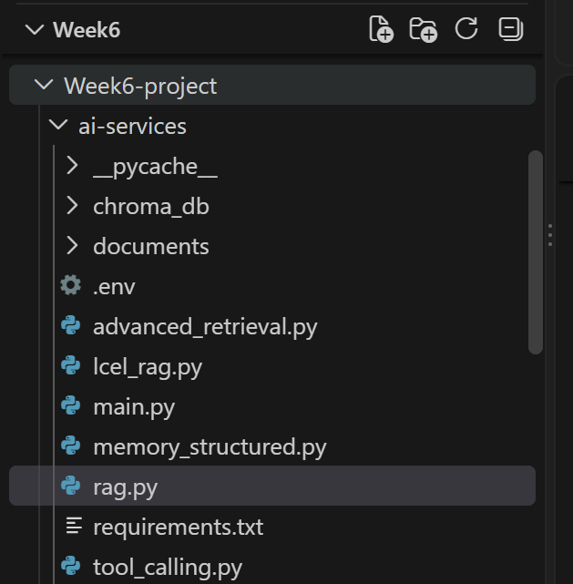
- Add the availability tool: the new .NET /availability endpoint plus the bound LangChain tool from Part D. Branch: feature/availability-tool.
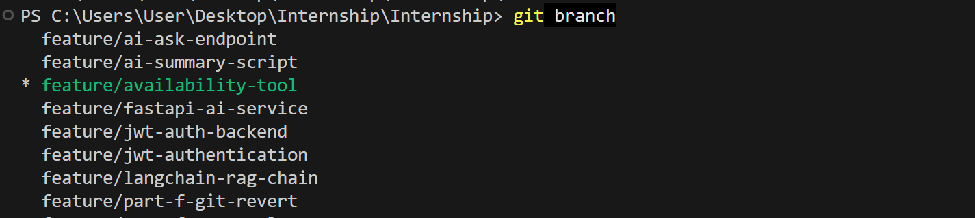
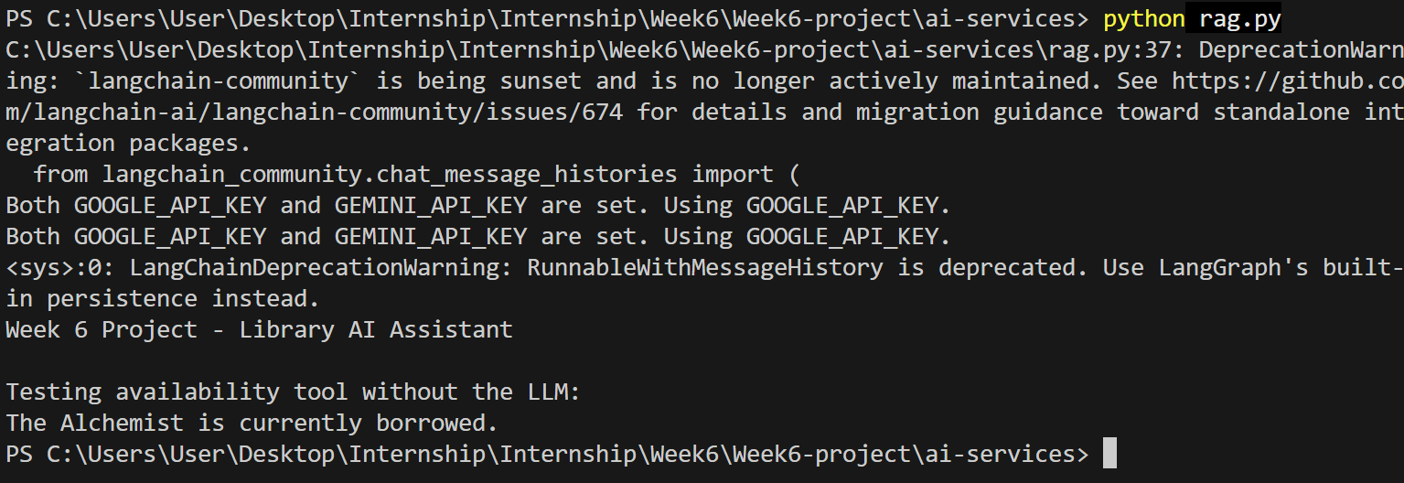
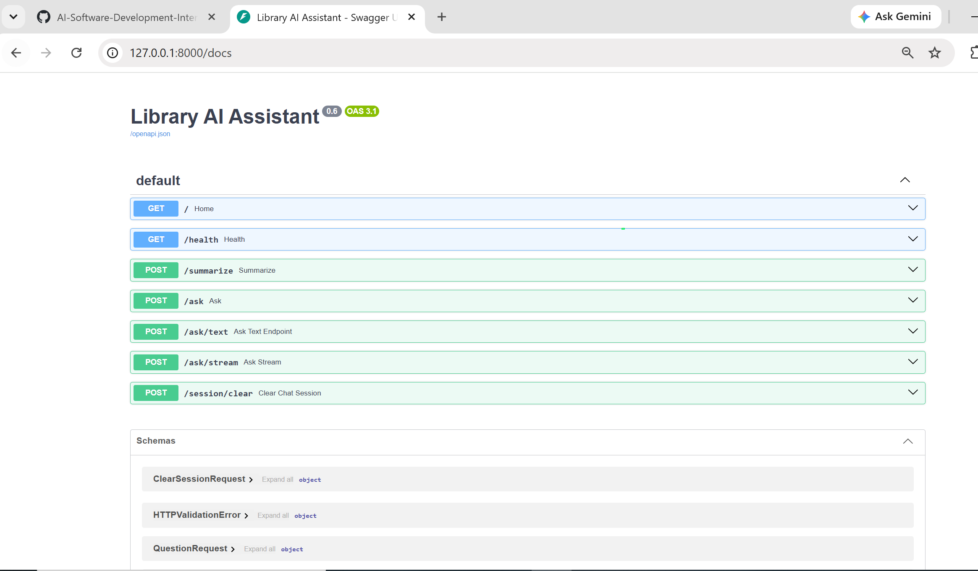
- Build the resilient AI service client in .NET with retry, timeout, and circuit-breaker policies, and a new POST /api/assistant/ask endpoint that Angular will call. Branch: feature/resilient-ai-client.
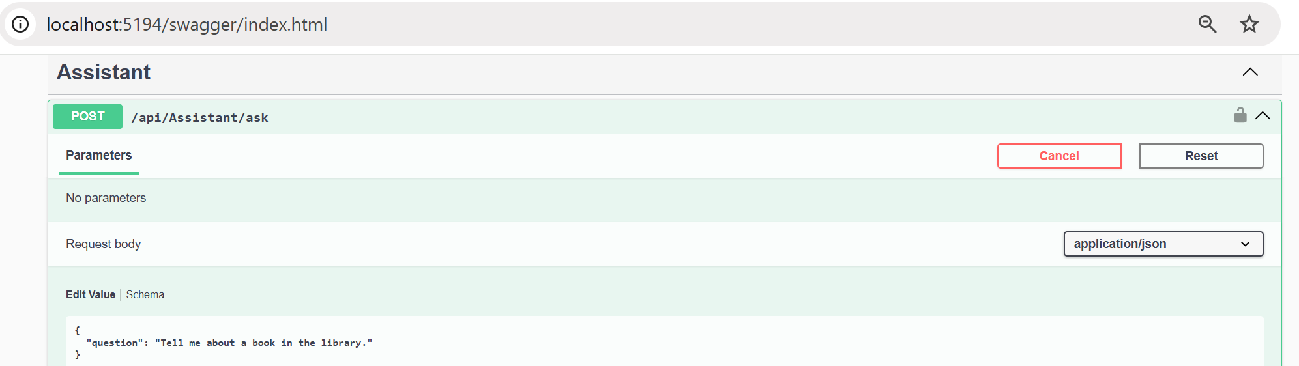
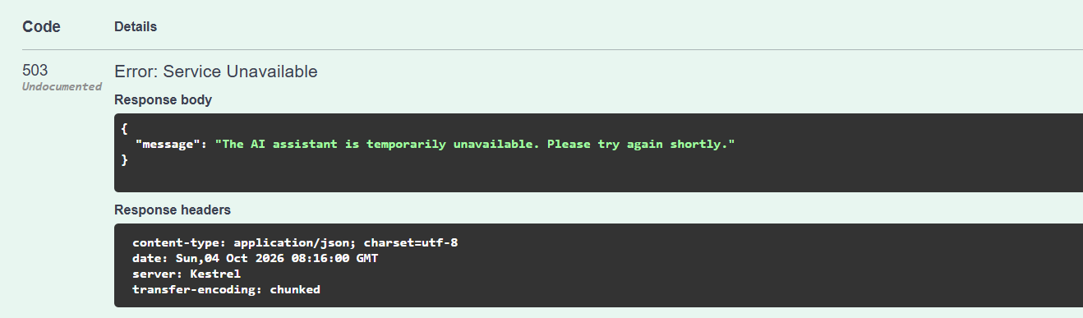
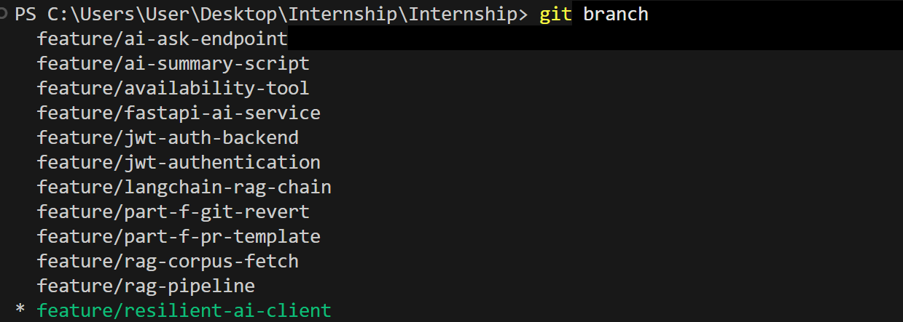
- Wire up streaming end to end for /api/assistant/ask/stream, and build a minimal chat UI in Angular showing the answer streaming in live. Branch: feature/streaming-chat-ui.
- Prove resilience under failure: with the AI service stopped, confirm the chat UI shows a clear "temporarily unavailable" state instead of hanging or crashing.
- Prove memory works: hold a short multi-turn conversation in the chat UI where a follow-up question only makes sense
Test 1 — Streaming UI:
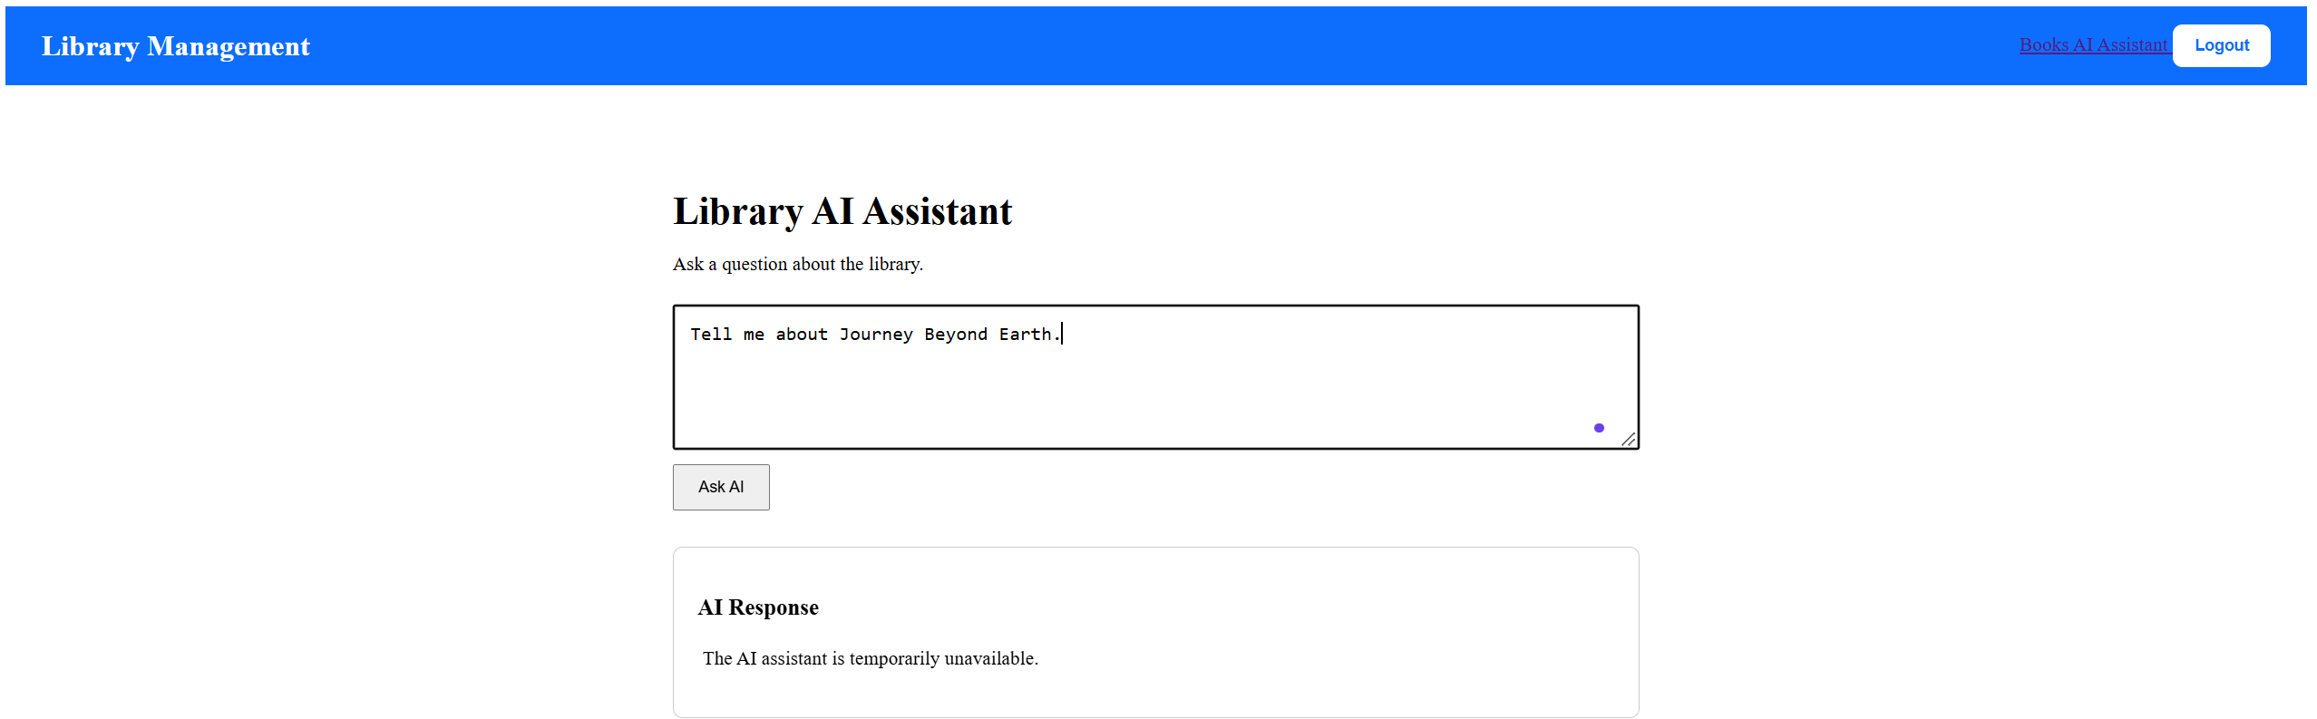
Test 2 — Availability through the real UI:
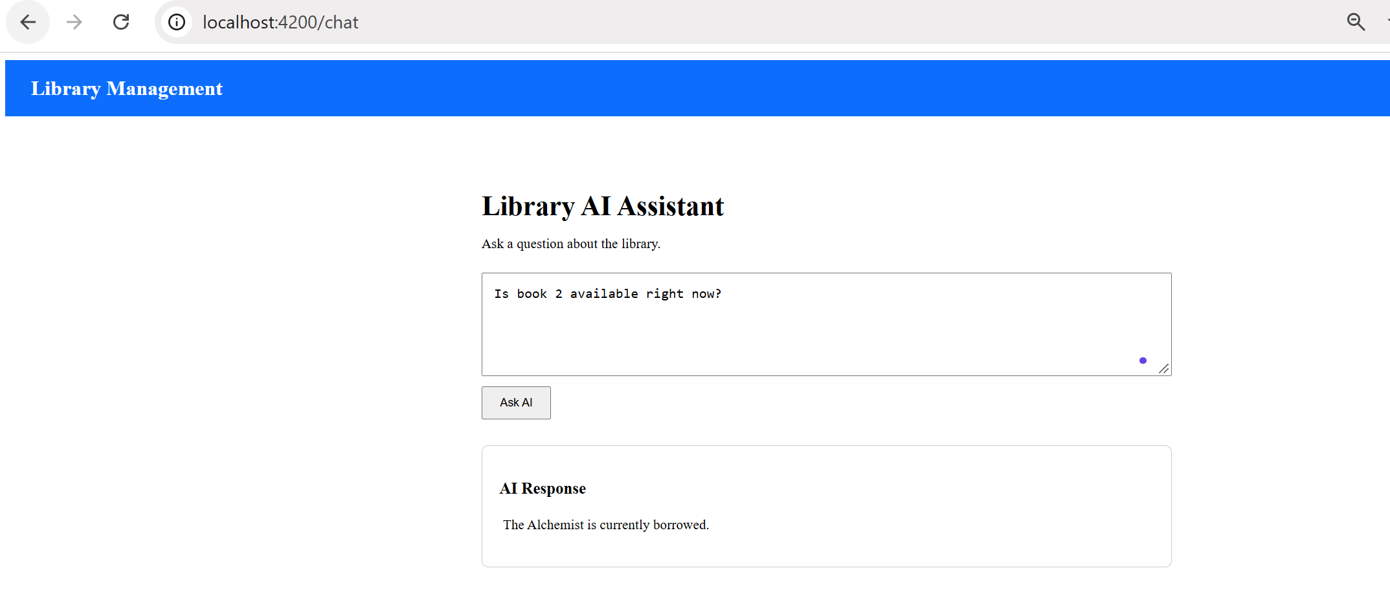
Test 3 — Prove failure handling in the UI:
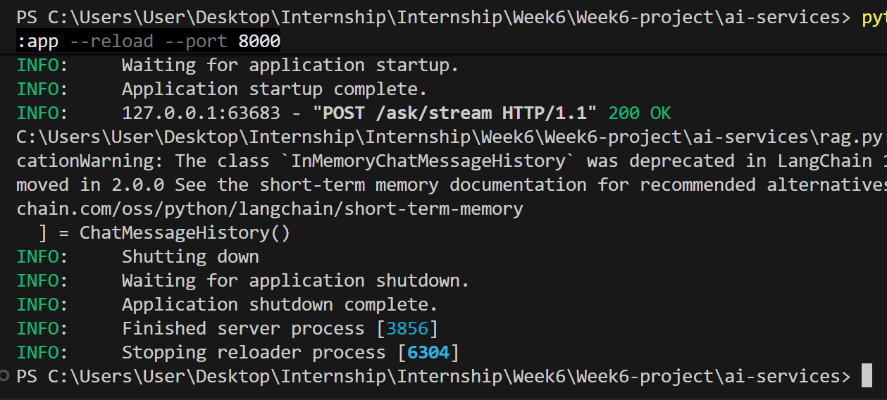
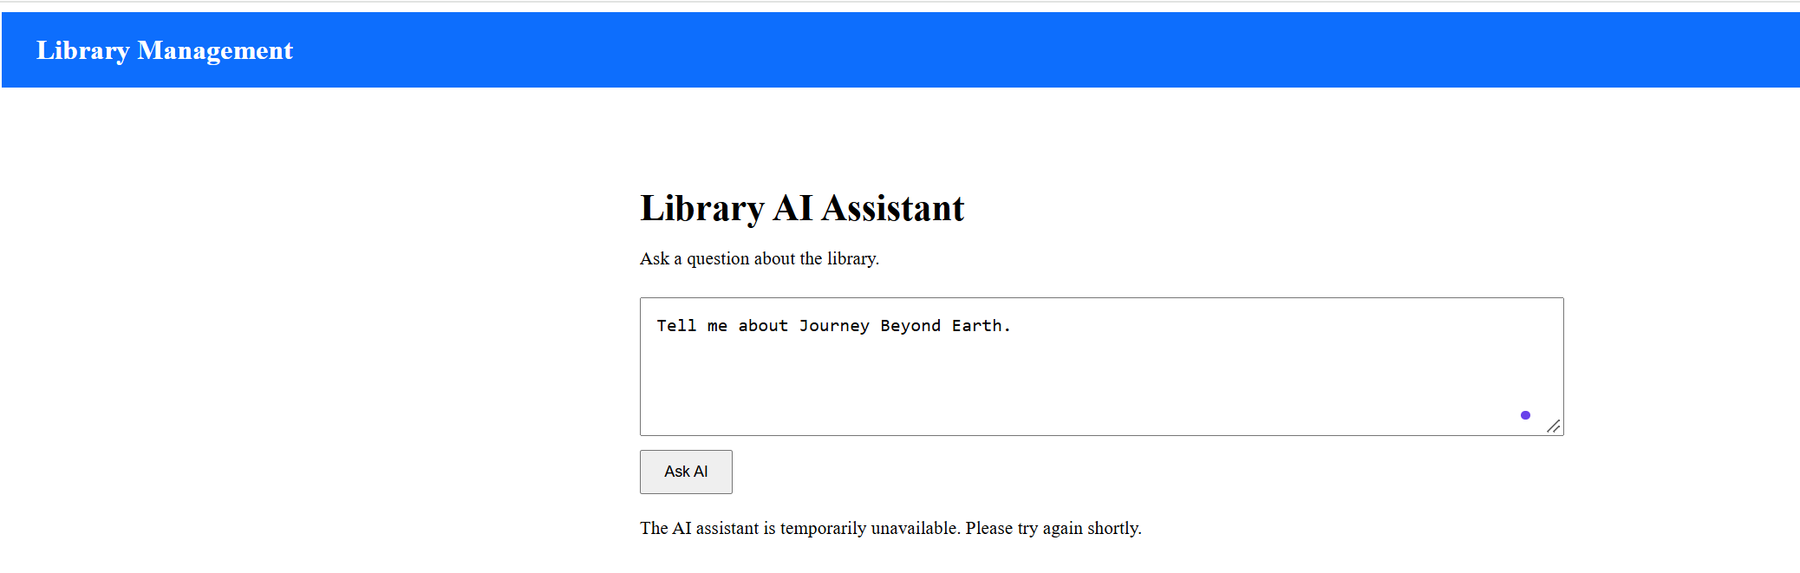

Test 4 — Memory:
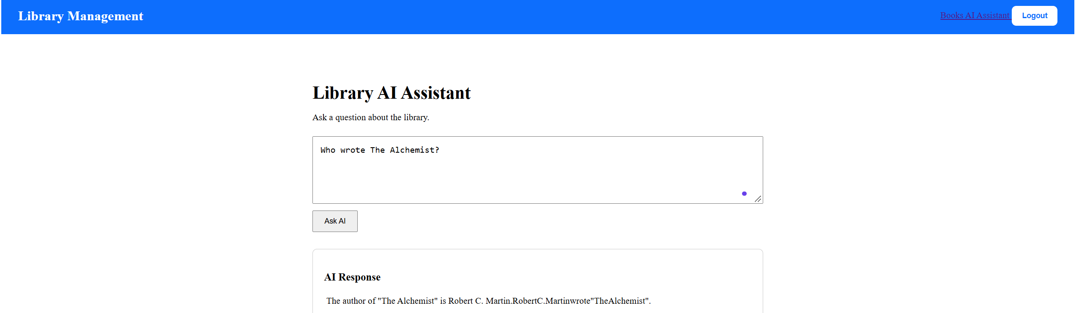
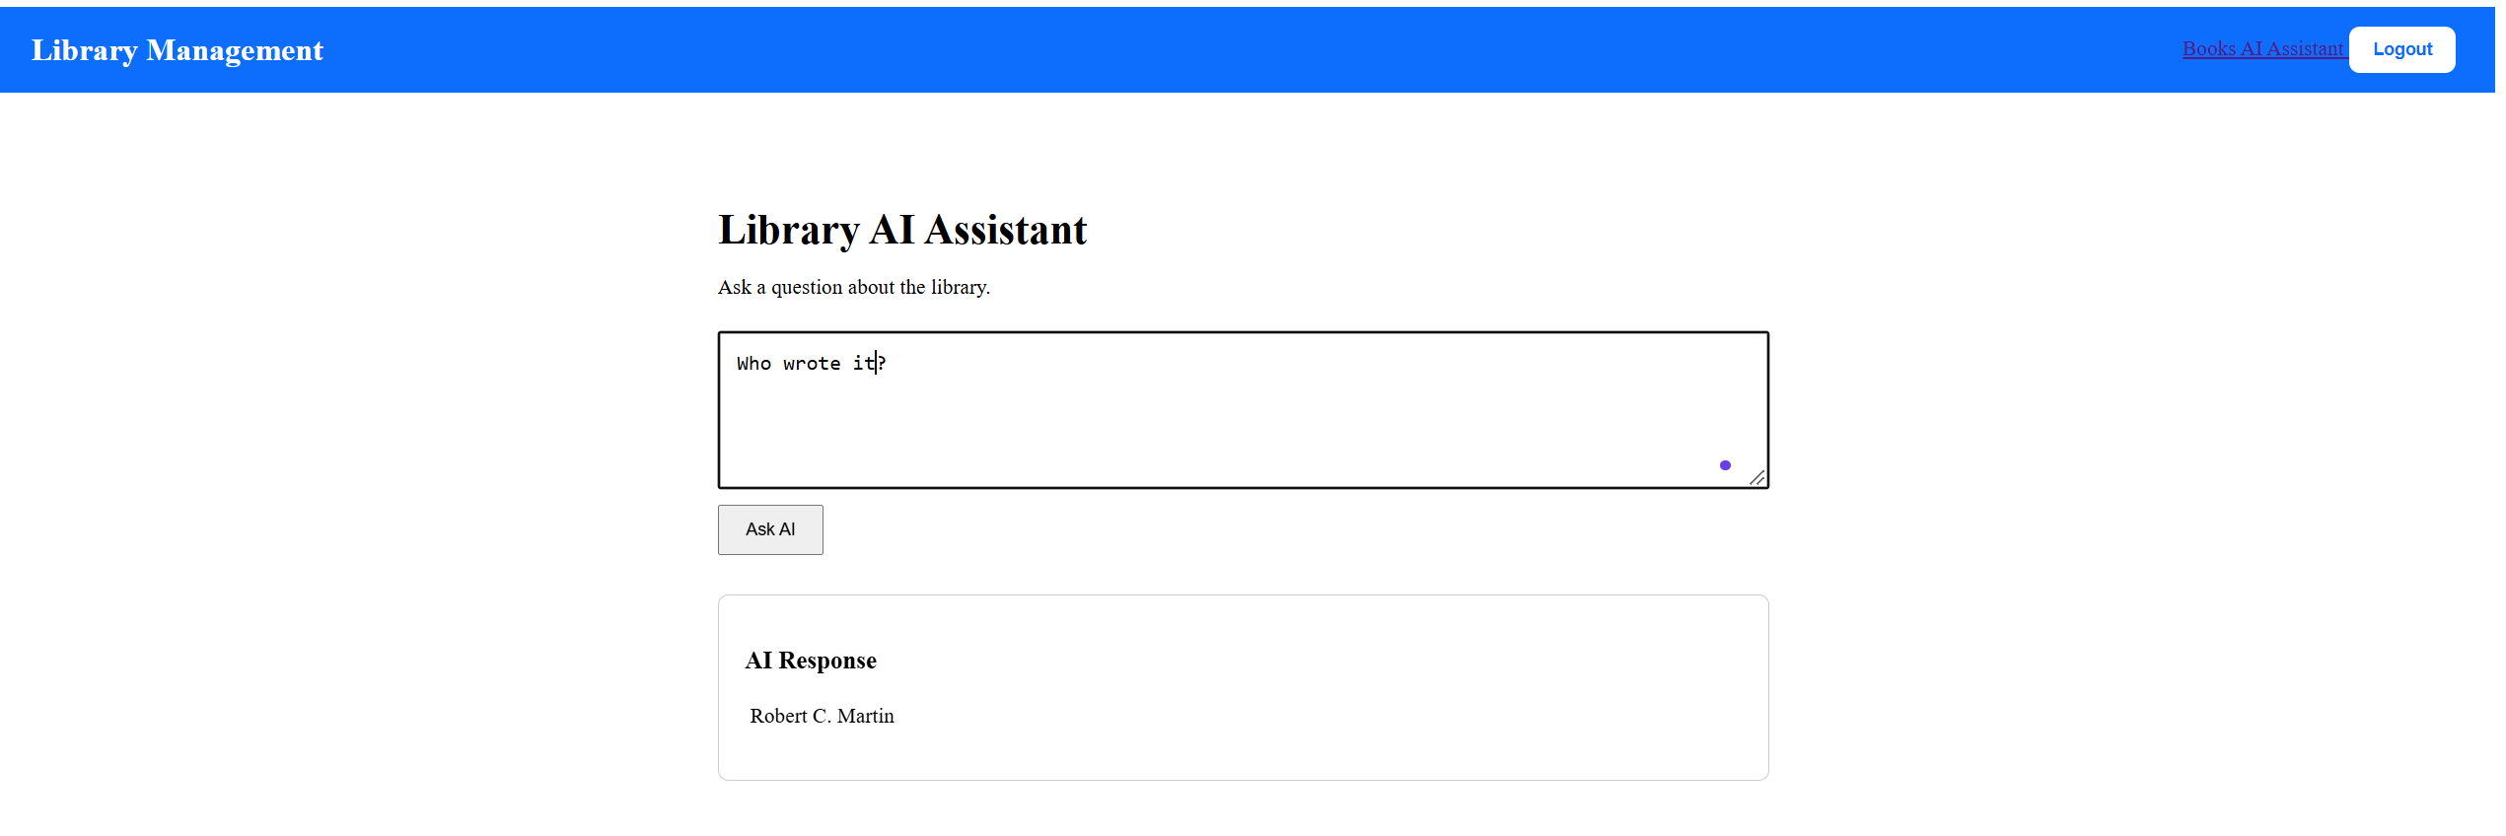

- with memory of the previous turn, and confirm it's answered correctly.
- Clean at least one branch's history with interactive rebase (Part G) before opening its PR.
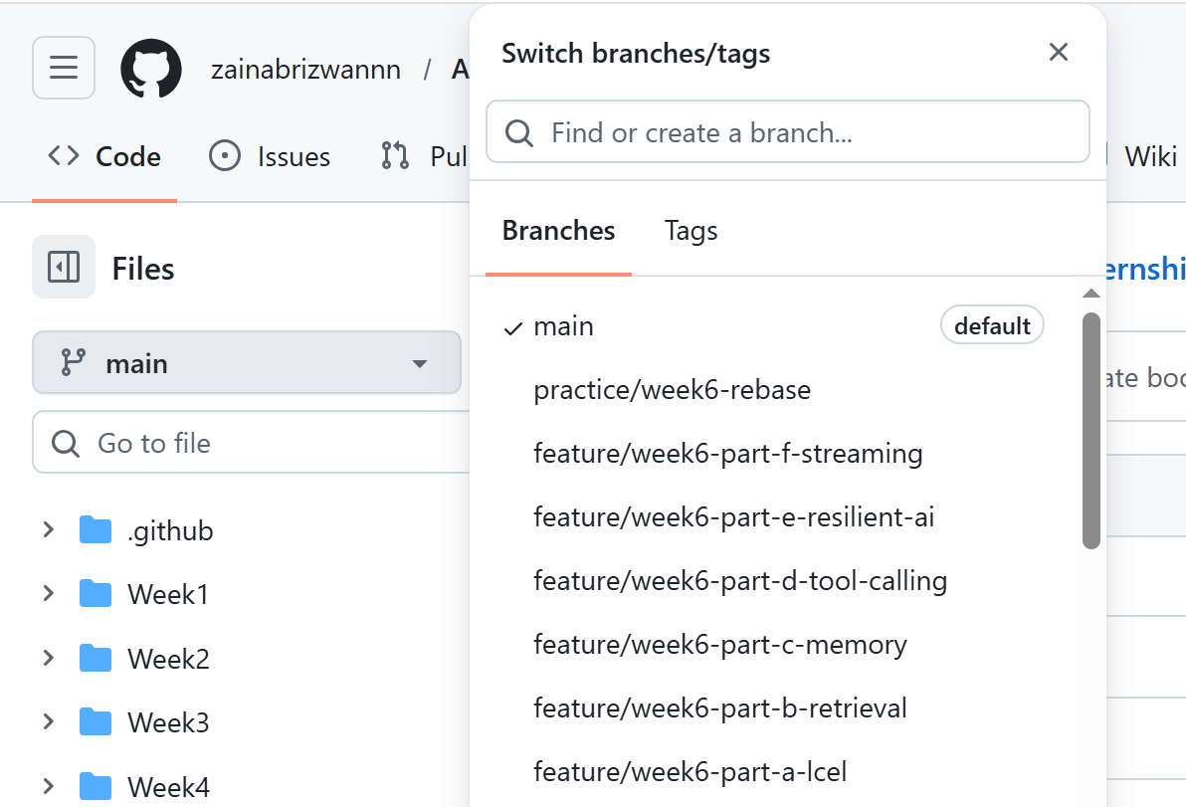

- Document the full data flow in the README: Angular chat UI fi .NET /api/assistant/ask/stream (resilient client) fi FastAPI /ask/stream (LangChain chain: retriever + tool + memory) fi LLM fi streamed back through both proxies to the UI. Include a short "known limitations" note (in-memory session store, no persistence). 9 Merge everything through reviewed Pull Requests. 10 Tag the milestone: git tag -a v0.6-week6 -m "Week 6: LangChain RAG, tool calling, resilient streaming integration" then push the tag.
